NICARAGUA

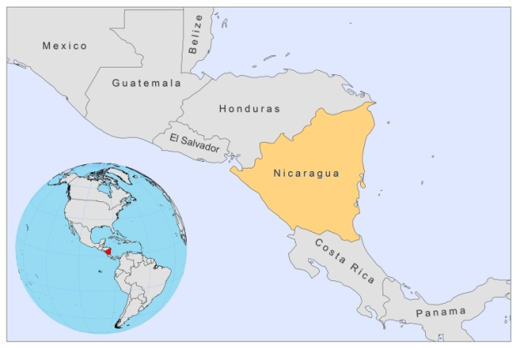

BASIC COUNTRY DATA

Total Population: 5,788,163
Population 0-14 years: 34%
Rural population: 43%
Population living under USD 1.25 a day: 15.8%
Population living under the national poverty line: no data
Income status: Lower middle income economy
Ranking: Medium human development (ranking 129)
Per capita total expenditure on health at average exchange rate (US dollar): 105
Life expectancy at birth (years): 73
Healthy life expectancy at birth (years): 61

BACKGROUND INFORMATION

Leishmaniasis was described in Nicaragua for the first time in 1917. Four clinical forms are present in the country: conventional CL, MCL, atypical CL, and VL [1]. CL is widespread in the central highlands and the Atlantic lowland plains and it is caused by L.braziliensis and L.panamensis [2], although a hybrid of both species has been characterized in almost one third of the cases in the north of the country [3] .

Like in other countries in central America, atypical non-ulcerative CL caused by L.infantum is present, more specifically in the Pacific region, and may or may not be caused by previous VL [2,4]. It has been suggested that these cases, with atypical CL, could be a potential reservoir for L.infantum, and should be targeted in the control program [4].

CL incidence is approximately 3.8/100,000 inhabitants, which makes this the country with the highest number of CL and MCL cases in Central America.

VL was first reported in 1994 [5].

PARASITOLOGICAL INFORMATION

Leishmania species | Clinical form | Vector species | Reservoirs
L. infantum | ZVL, CL | Lu. longipalpis, Lu. evansi | Canis familiaris
L. panamensis | ZCL | Lu. trapidoi, Lu. ylephiletor,  Lu. cruciata, Lu. panamensis | unknown
L. braziliensis | ZCL, MCL | Lu. panamensis | unknown

MAPS AND TRENDS

Visceral leishmaniasis
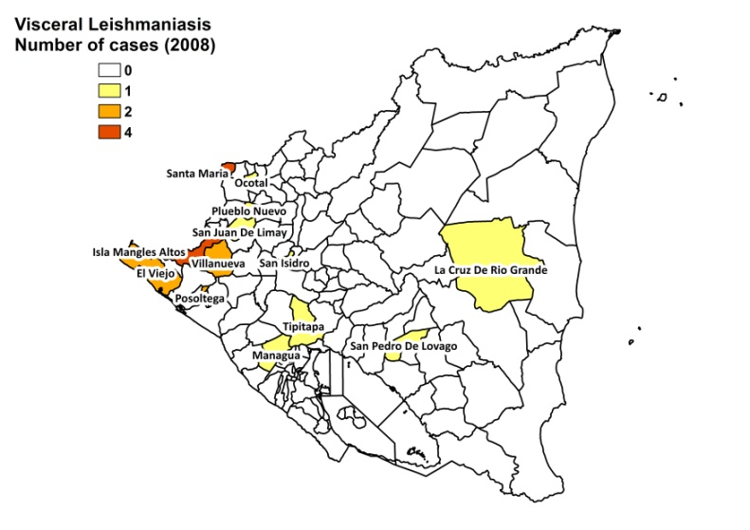

Cutaneous leishmaniasis

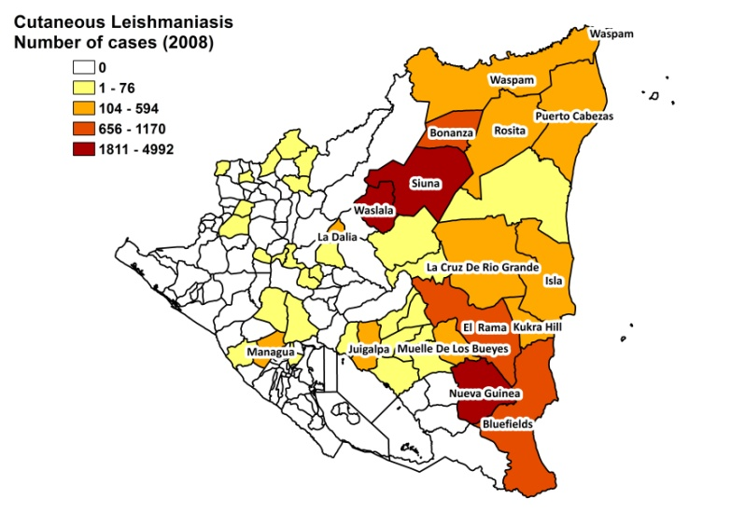
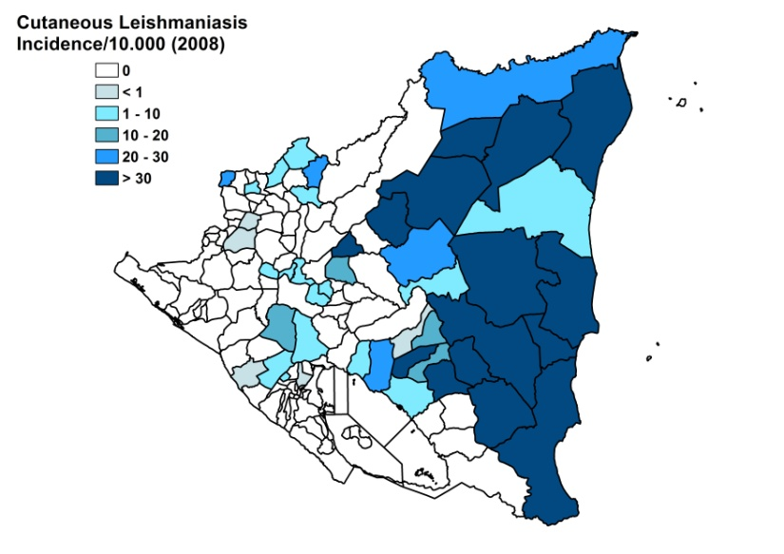

Cutaneous leishmaniasis trend

Number of cutaneous and mucocutaneous leishmaniasis cases

 | 2008 | 2009 | 2010
CL cases | 5941 | 4110 | 3570
MCL cases | 34 | 30 | 31
MCL % of CL cases | 5.6 | 7.2 | 8.6

Visceral leishmaniasis cases

2003 | 2004 | 2005 | 2006 | 2007 | 2008 | 2009 | 2010
5 | 5 | 1 | 1 | 1 | 4 | 1 | 1

CONTROL

Leishmaniasis has been a notifiable disease since 1980. A leishmaniasis control program was established in 1994. The vector-control strategy adopted relies on controlling foci (spatial spraying in a 500 m radius, using a portable motorized sprayer) and using treated bednets. There is under-reporting of the disease and a lack of systematic monitoring of patients and focused vector-control measures.

DIAGNOSIS, TREATMENT

Diagnosis:
CL: microscopic examination of skin lesion sample, Montenegro skin test, IFAT, PCR.
VL: IFAT, PCR.

Treatment:
CL: antimonials.
VL: antimonials.
ACCESS TO CARE

The Ministry of Health provides 95% coverage and is assisted by two NGO’s, that help carry out some activities, such as staff training, drug procurement and medical consultations, etc.

ACCESS TO DRUGS

Glucantime (Sanofi) is registered.

SOURCES OF INFORMATION
- Dr Emperatriz Lugo. Leishmaniasis en la Región de las Américas. Reunión de coordinadores de Programa Nacional de Leishmaniasis. OPS/OMS. Medellín, Colombia. 4-6 junio 2008.

1. Missoni E, Morelli R (1984). Survey of 259 cases of American cutaneous leishmaniasis in Nicaragua. J Trop Med Hyg 87:159-65.

2. Darce M, Moran J, Palacios X, Belli A, Gomez-Urcuyo F et al (1991). Etiology of human cutaneous leishmaniasis in Etiology of human cutaneous leishmaniasis in Nicaragua. Trans R Soc Trop Med Hyg 85(1):58-9.

3. Belli AA, Miles MA, Kelly JM (1994). A putative Leishmania panamensis/Leishmania braziliensis hybrid is a causative agent of human cutaneous leishmaniasis in Nicaragua. Parasitology 109 (4):435-42.

4. Belli A, García D, Palacios X, Rodriguez B, Valle S et al (1999). Widespread atypical cutaneous Leishmaniasis caused by Leishmania (L.) chagasi in Nicaragua. Am J Trop Med Hyg 61:380-5.

5. Duarte Z, Munguia J, Orozco M, Gantier JC (1994) First report of visceral leishmaniasis in Nicaragua. Trans R Soc Trop Med Hyg 88: 38.

