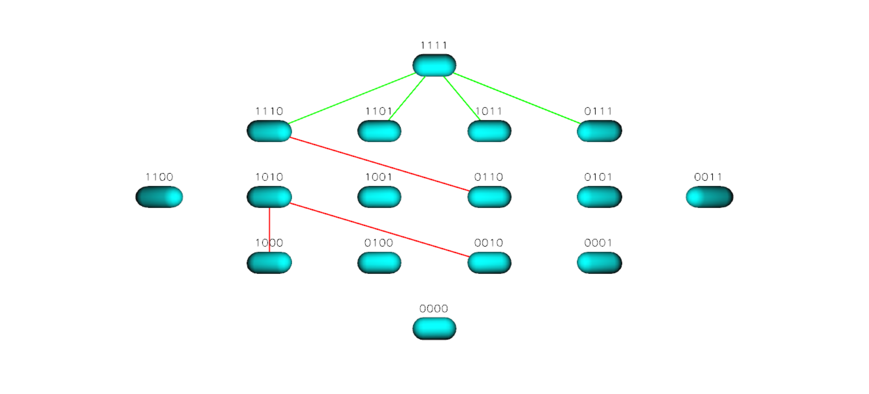
Figure S24 TEM 85 Landscape for Cefuroxime

