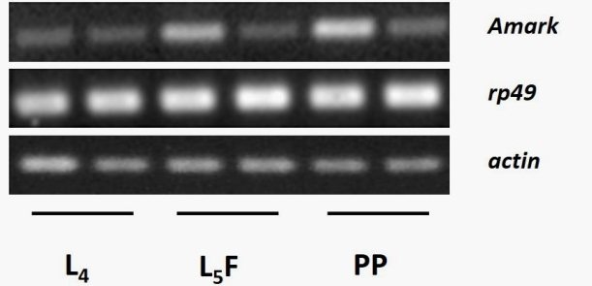

Supporting Information Figure S1 - Amark gene expression in the ovaries of workers (W) and queens (Q) at the fourth larval instar (L₄), at the feeding phase of the fifth larval instar (L₅F) and at the prepupal phase (PP). Semiquantitative RT-PCR using rp49 (GenBank accession number NM_001011587) and actin (GenBank accession numberAB023025.1) as reference genes. Each sample is a pool made with five ovary pairs. PCR products were detected after electrophoresis on ethidium bromide-stained agarose gel.

