

Figure A. **Homoscedasticity and normality of errors of model 1 to estimate individual-tree aboveground biomass of cerrado *sensu stricto*.**



Figure B. **Homoscedasticity and normality of errors of model 2 to estimate individual-tree aboveground biomass of cerrado *sensu stricto*.**



Figure C. **Heteroscedasticity and non-normality of errors of model 3 to estimate individual-tree aboveground biomass of cerrado *sensu stricto*.**



Figure D. **Heteroscedasticity and non-normality of errors of model 4 to estimate individual-tree aboveground biomass of cerrado *sensu stricto*.**



Figure E. **Homoscedasticity and normality of errors of model 5 to estimate individual-tree aboveground biomass of cerrado *sensu stricto*.**



Figure F. **Homoscedasticity and normality of errors of model 6 to estimate individual-tree aboveground biomass of cerrado *sensu stricto*.**



Figure G. **Homoscedasticity and normality of errors of model 7 to estimate individual-tree aboveground biomass of cerrado *sensu stricto*.**



Figure H. **Homoscedasticity and normality of errors of model 8 to estimate individual-tree aboveground biomass of cerrado *sensu stricto*.**



Figure I. **Homoscedasticity and normality of errors of model 9 to estimate individual-tree aboveground biomass of cerrado *sensu stricto*.**



Figure J. **Homoscedasticity and normality of errors of model 10 to estimate individual-tree aboveground biomass of cerrado *sensu stricto*.**



Figure K. **Homoscedasticity and normality of errors of model 11 to estimate individual-tree aboveground biomass of cerrado *sensu stricto*.**



Figure L. **Homoscedasticity and normality of errors of model 12 to estimate individual-tree aboveground biomass of cerrado *sensu stricto*.**

Plot biomass class center (ton ha-1)

Plot biomass class center (ton ha-1)

Theoretical quantiles

Theoretical quantiles

A

B



Figure M. **Homoscedasticity and normality of errors of model 13 to estimate tree aboveground plot biomass density of cerrado *sensu stricto*.**



Figure N. **Homoscedasticity and normality of errors of model 14 to estimate tree aboveground plot biomass density of cerrado *sensu stricto*.**



Figure O. **Homoscedasticity and normality of errors of model 15 to investigate environmental influences over tree aboveground biomass density of cerrado *sensu stricto* in Cerrado, Brazil.**



Figure P. **Homoscedasticity and normality of errors of model 16 to investigate environmental influences over tree aboveground biomass density of cerrado *sensu stricto* in Cerrado, Brazil.**

 Figure Q. **Homoscedasticity and normality of errors of model 17 to investigate environmental influences over tree aboveground biomass density of cerrado *sensu stricto* in Cerrado, Brazil.**



Figure R. **Homoscedasticity and normality of errors of model 18 to investigate environmental influences over tree aboveground biomass density of cerrado *sensu stricto* in Cerrado, Brazil.**



Figure S. **Homoscedasticity and normality of errors of model 19 to investigate environmental influences over tree aboveground biomass density of cerrado *sensu stricto* in Cerrado, Brazil.**

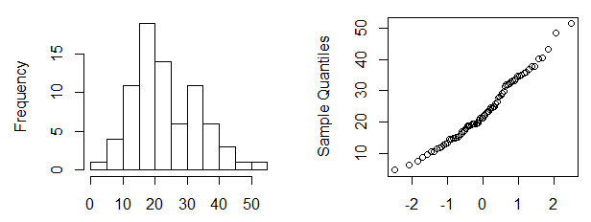

Site biomass class center (ton ha-1) Theoretical Quantiles

Figure T. **Histogram and QQ-Norm plot of tree-aboveground biomass density of 77 cerrado *sensu stricto* sites in Brazil, estimated using model 11.**

****

Figure U. **Boxplot of tree aboveground biomass density of 77 cerrado *sensu stricto* 77 sites in Brazil, estimated with model 11.**



Figure V**. Cluster analysis dendrogram for tree aboveground biomass density 77 cerrado *sensu stricto* sites in Brazil, estimated with model 11.**