MetaGeniE: Characterizing Human Clinical Samples Using Deep Metagenomic Sequencing

Arun Rawat^{1*}, David M. Engelthaler¹, Elizabeth M. Driebe¹, Paul Keim^{1,2}, Jeffrey T. Foster^{2,3*}

¹Pathogen Genomics Division, Translational Genomics Research Institute, Flagstaff, Arizona, United States of America
²Center for Microbial Genetics and Genomics, Northern Arizona University, Flagstaff, Arizona, United States of America
³Department of Molecular, Cellular, and Biomedical Sciences, University of New Hampshire, Durham, New Hampshire, United States of America

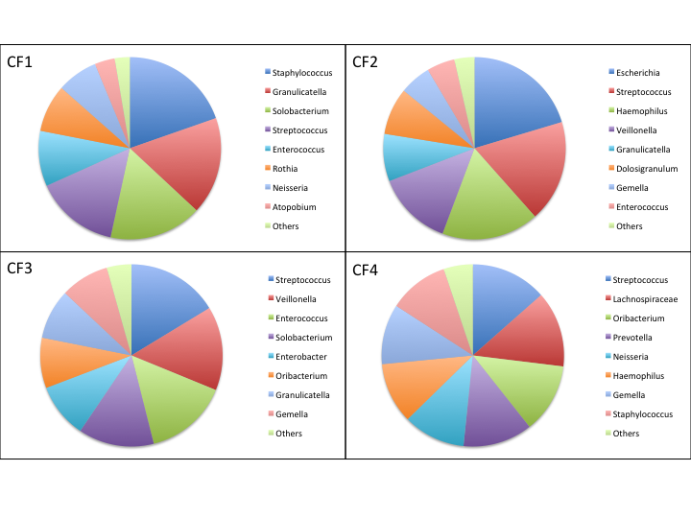
Figure S4. Distribution of microbial community across the four cystic fibrosis samples (Top Hit per Genus is represented; Minimum genome coverage percent >10%, Genome Size >100,000; Scaffolds do not represent whole genomes and might be overrepresented).

