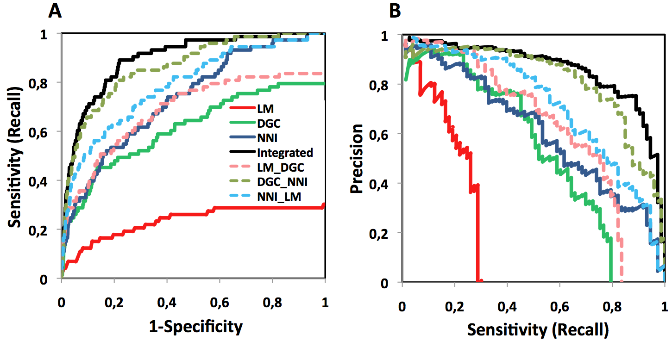

Supplementary Figure S1. Validation of the LM, NNI and DGC methods. Validation of the pair-wise combination of methods against the text mined, manually curate dataset EXPERT gold standard, used as true positives. The DGC_NNI, NNI_LM and LM_DGC combinations are shown together with the single LM, NNI and DGC predictions and the integration of all of them. (A) ROC curves: Sensitivity (also called Recall; y-axis) versus 1-Specificity (x-axis). And (B) PR curves: Precision (y-axis) versus Recall (x-axis) retrieved by each method and their pairwise combination.

