Figure_S2: Quantile-quantile plots for genome-wide application of our EMA discovery cohort tests.
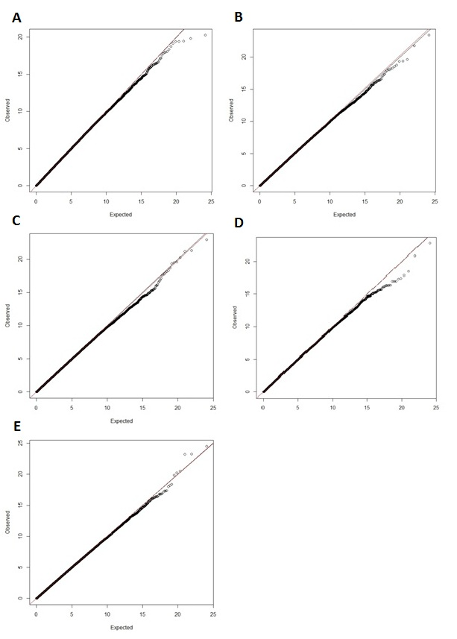
A) Quantile-quantile plot for our CMH test of allele frequency in the EMA offspring (proband main effects), λ = 1.002. B) Quantile-quantile plot for our CMH test of allele frequency in the EMA mothers (maternal main effects), λ = 1.011. C) Quantile-quantile plot for our CMH test of pair-types using the “Offspring Heterozygous” model, λ = 0.991. D) Quantile-quantile plot for our CMH test of pair-types using the “Maternal Heterozygous” model, λ = 0.997. E) Quantile-quantile plot for our CMH test of pair-types using the “Difference” model, λ = 0.998.

