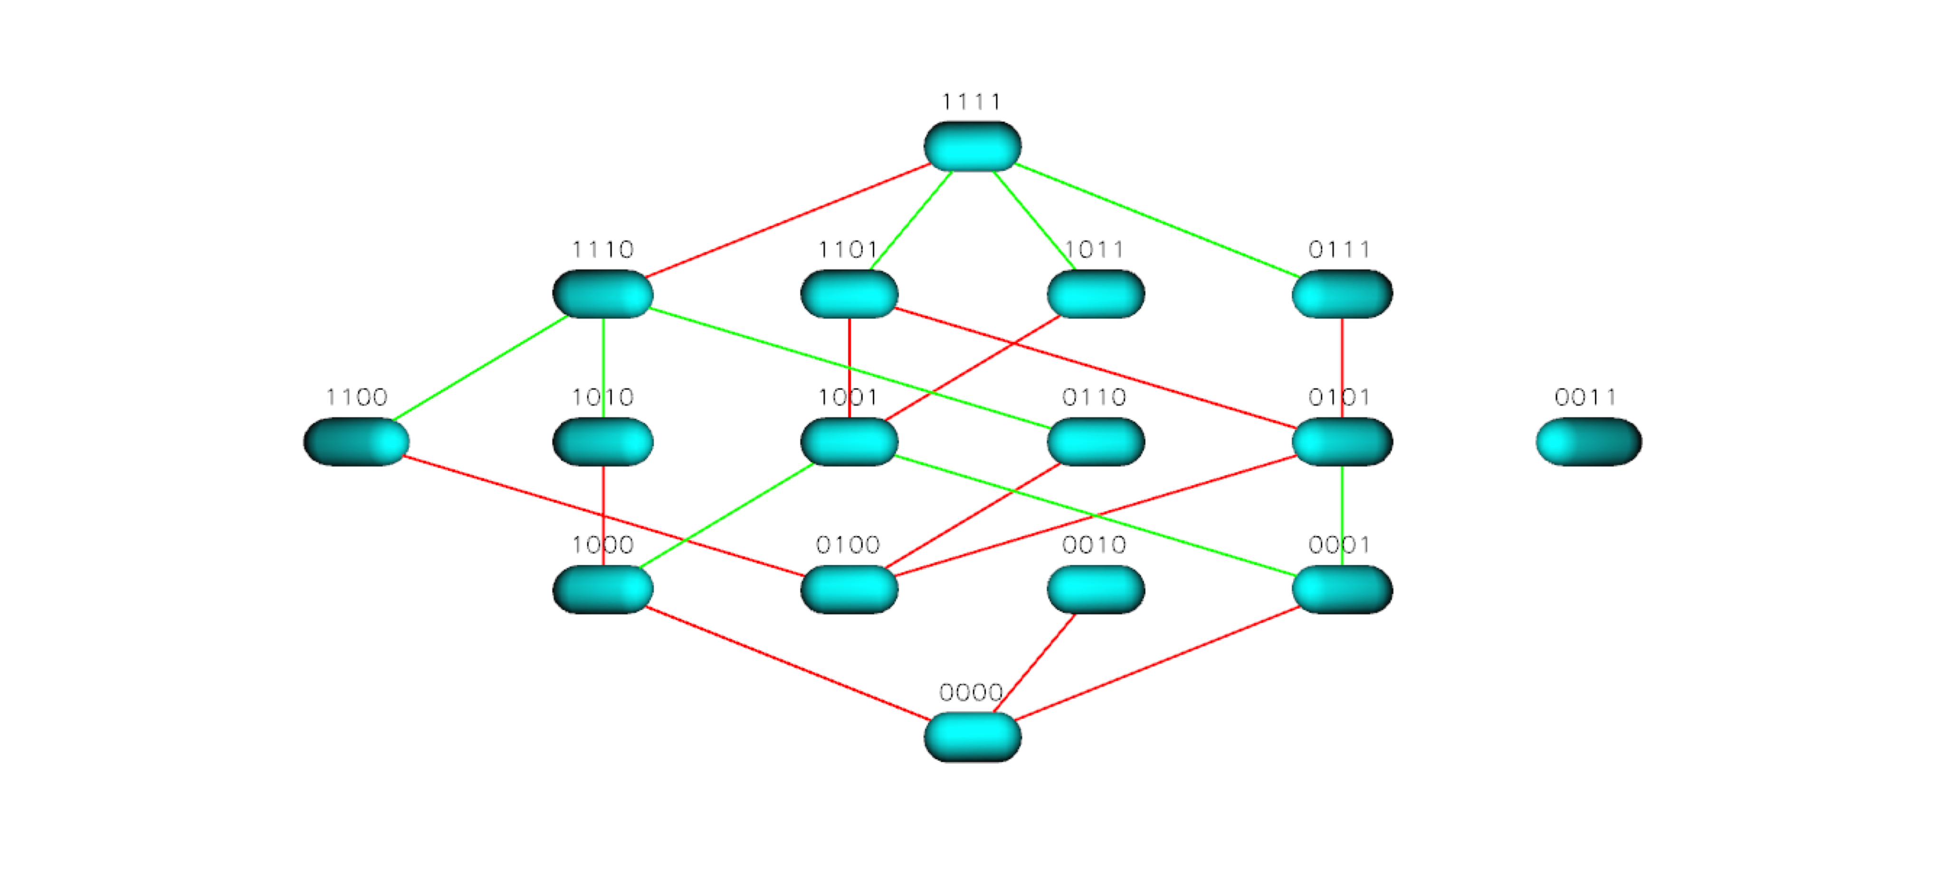
Figure S7 TEM 50 Landscape for Cefotetan

