Appendix 2
Appendix 2 Fig 1 depicts boxplots of each score against user rating. Appendix 2 Figs 2-5 depict boxplots of each score against download level. Above each box plot is a number indicating the sample size. Sample size (depicted in the Figs) varied from 1 to 177, this is because download level ‘1,2,3 and 19’ has a sample size of 0 and was not included in the Fig.
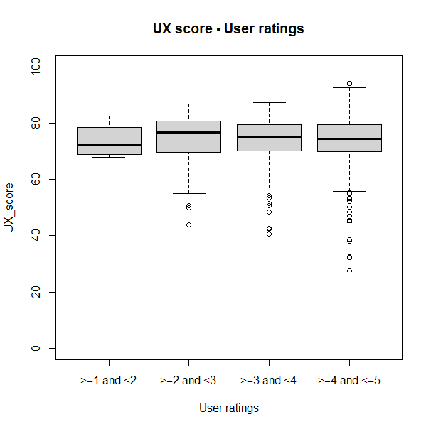
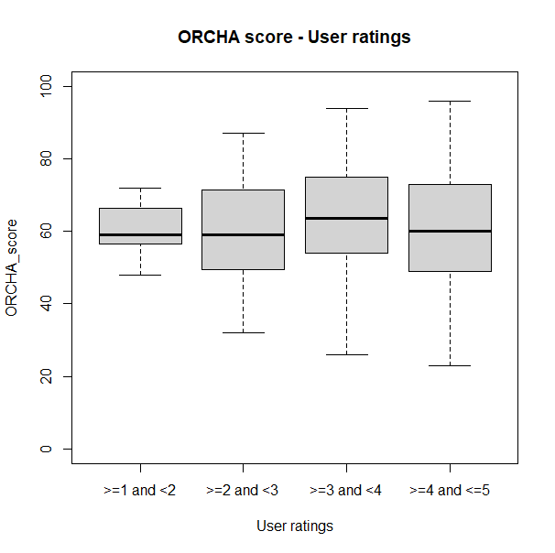
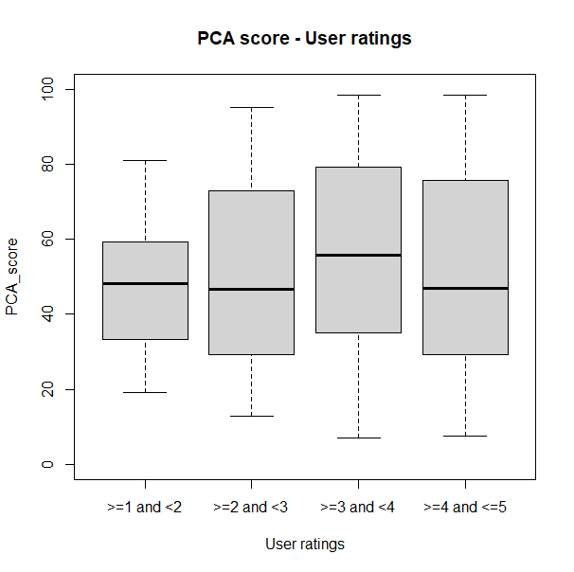
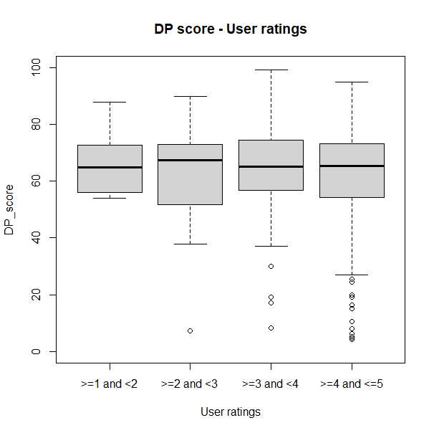
8
43
222
608
8
43
222
608
8
43
222
608
8
43
222
608
a) b)
c) d)

Appendix 2 Fig 1: Numbers above boxplots are sample sizes. a) ORCHA score against user ratings boxplots. b) UX score against user ratings boxplots. c) PCA score against user ratings boxplots. d) DP score against user ratings boxplots.

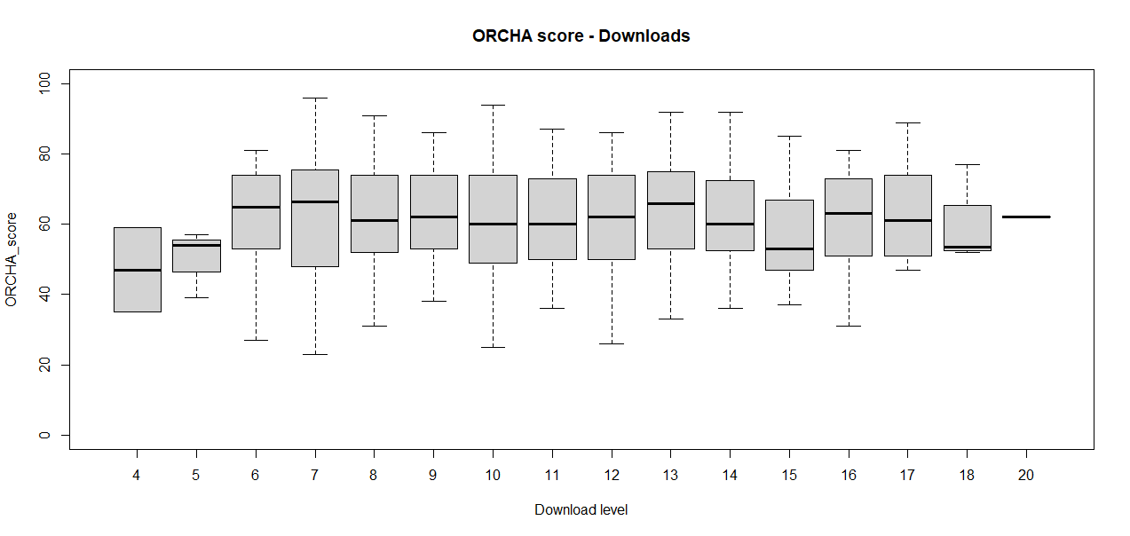
2
3
30
28
139
70
177
70
134
61
72
31
53
6
4
1

Appendix 2 Fig 2: ORCHA score against download level boxplots.

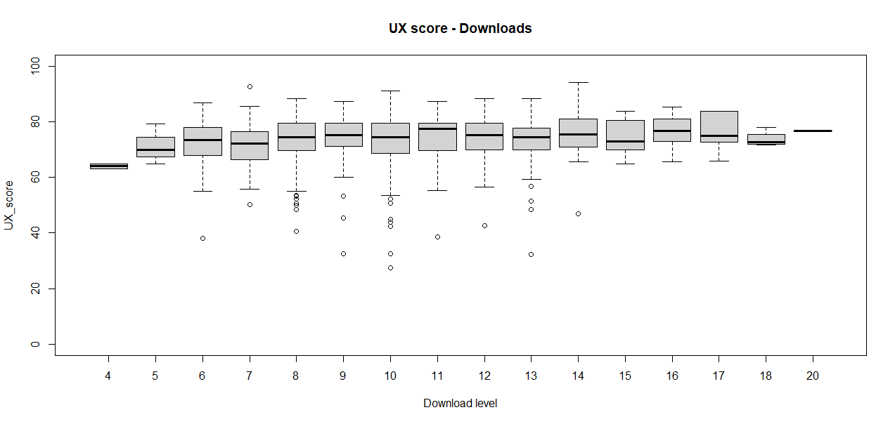
2
3
30
28
139
70
177
70
134
61
72
31
53
6
4
1

Appendix 2 Fig 3: UX score against download level boxplots.

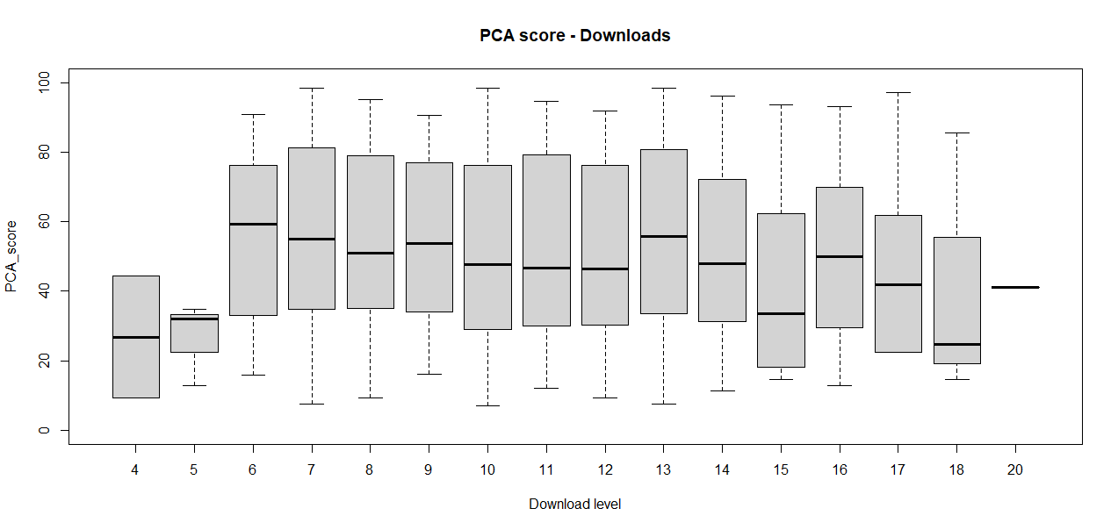
2
3
30
28
139
70
177
70
134
61
72
31
53
6
4
1

Appendix 2 Fig 4: PCA score against download level boxplots.

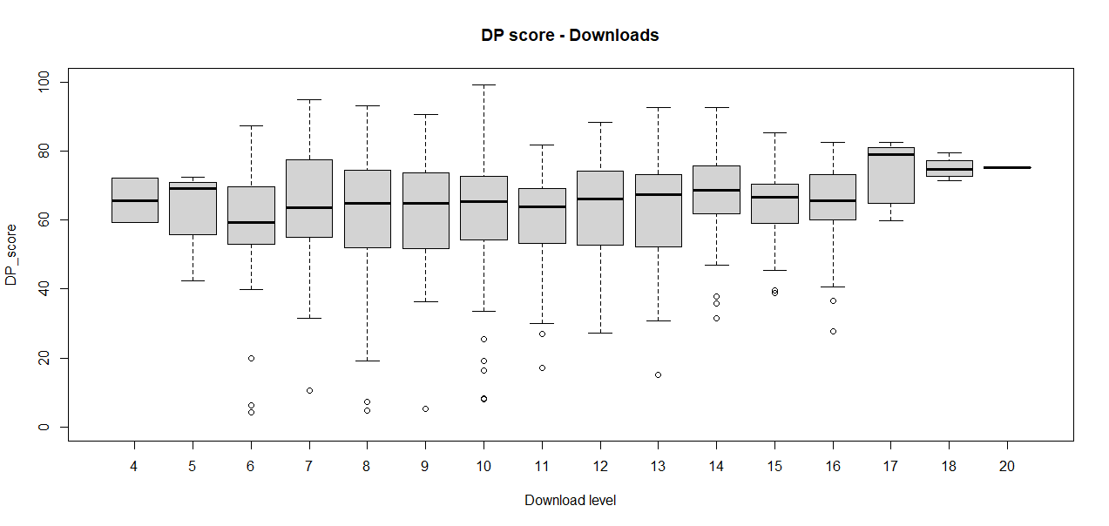
2
3
30
28
139
70
177
70
134
61
72
31
53
6
4
1

Appendix 2 Fig 5: DP score against download level boxplots.

