Supporting Information 2 (S2)
Supplementary Figure

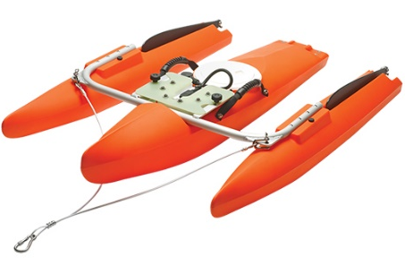

S2 Fig1: ADCP (Acoustic Doppler current profiler) device

S2 Fig2: Identification of Outfalls in Left Bank of the river Ganga from South to North during 2014 from Howrah Station to Khardah, 24 Parganas (North), West Bengal, India
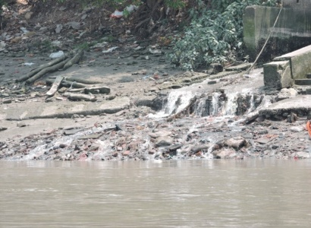  Annapurna Ghat, Bagbazar  N22⁰36'19.2'' E088⁰21'53.5'' | 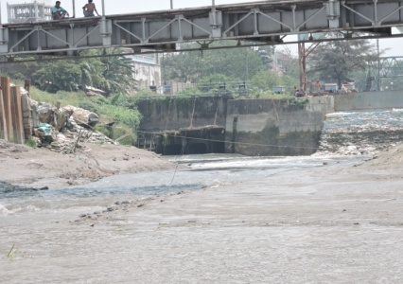  Circular Canal, Bagbazar  N22⁰36'29.66" E088°22'00.96" |  | 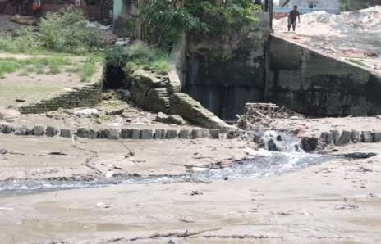  Jaymataji Ghat, Chitpur  N22⁰36'48.6'' E088⁰22'06.2''
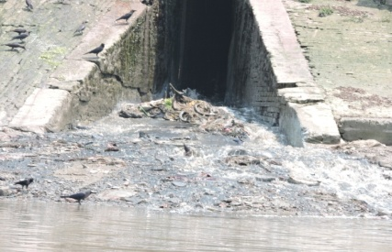  Cossipore area I, Cossipore  N22⁰37'02.3'' E088⁰22'05'' | 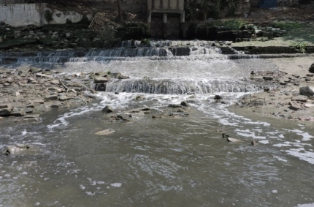  Cossipore area II, Cossipore  N22⁰37'08.2'' E088⁰22'05.3'' |  | 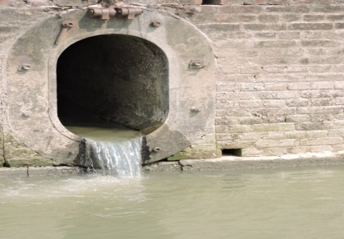  Alambazar, Baranagar  N22°38’52.0’’ E088°21’31.8’’
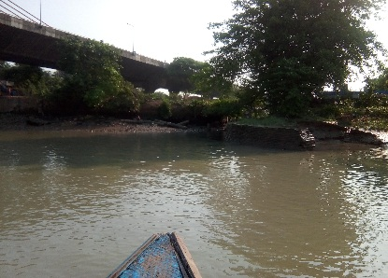  Dakshineswar Canal, Dakshineswar  N22°39'08.75'' E88°21'27.60'' | 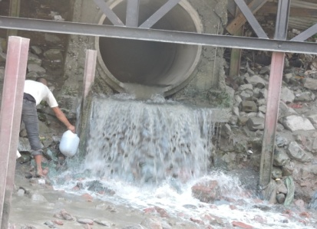  New Jetty, Dakshineswar  N22°39'13.2'' E088°21'27.1'' |  | 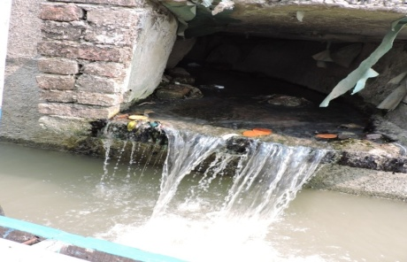  Patbari, Ariadaha  N22°40'04.6'' E088°21'31.3''
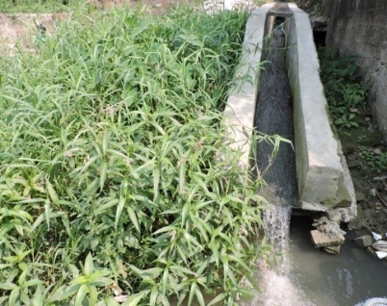  Fatik Mallik Ghat, Ariadaha  N22°40'10.3'' E088°21'33.9'' |  | 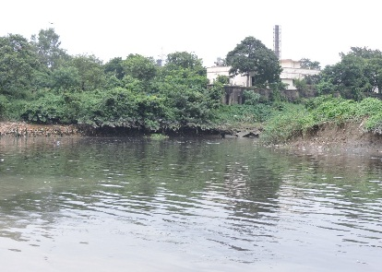  Khardah Khal, Khardah  N22°43'35.28" E088°21'42.97"

S2 Fig3: Identification of Outfalls in Right Bank of the river Ganga from South to North during 2014 from Howrah Station to Khardah, 24 Parganas (North), West Bengal, India
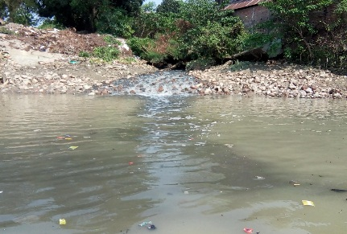  Ghusuri, Howrah  N22°36'37.18'' E088°21'26.37'' | 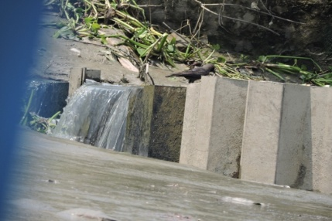  Jagannath Ghat, Belur Bazar  N22°37'42.9'' E088°21'33.3'' | 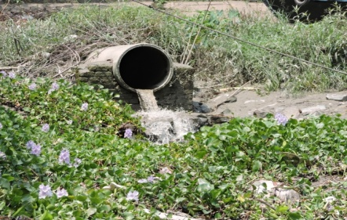  Kathgola Ghat, Belur  N22⁰37’48.8’’ E088⁰21’30.6’’
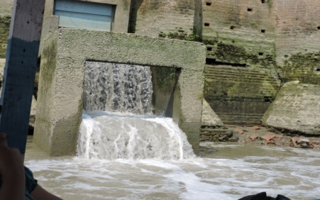  Rashbari Ghat, Belur  N22°38'14.6'' E088°21'18.3'' | 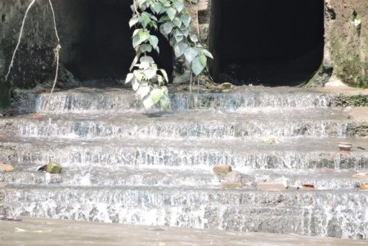  Dewangazi, Bally  N22°38'34.3'' E088°21'10.5'' | 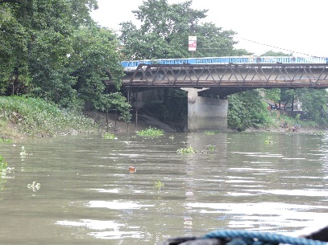  Ballykhal, Bally  N22°39'18.33’’ E088°20'58.75"
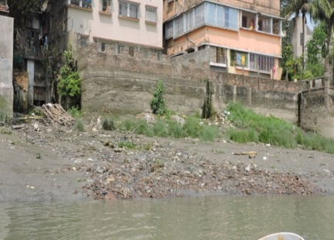  Ramghat, Uttarpara  N22°39'49.2'' E088°21'04.0'' | 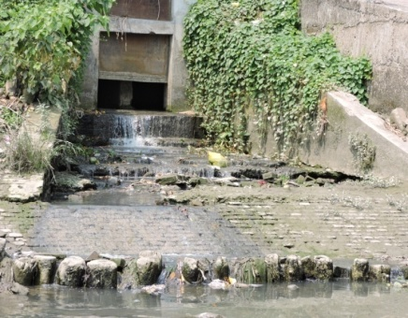  Doltala, Uttarpara  N22⁰40'05.2'' E088021'05.4'' | 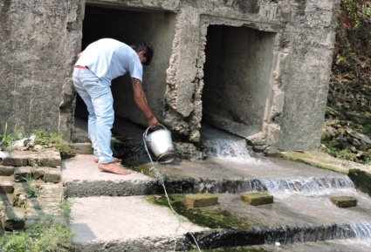  Bottala, Hindmotor  N22°40'55.3'' E088°21'21.2''

S2 Fig4: Zone of influence of DO, BOD, Nitrate nitrogen and Phosphorus at Circular Canal during pre-monsoon low tide | S2 Fig5: Zone of influence of DO and BOD at Circular Canal during monsoon low tide | S2 Fig6: Zone of influence of DO, BOD and Phosphorus at Circular Canal during post-monsoon low tide
S2 Fig7: Zone of influence of DO, BOD, Nitrate nitrogen and Phosphorus at Ghusuri during pre-monsoon low tide | S2 Fig8: Zone of influence of BOD at Ghusuri during monsoon low tide | S2 Fig9: Zone of influence of DO, BOD and Phosphorus at Ghusuri during post-monsoon low tide
S2 Fig10: Zone of influence of DO, BOD, Nitrate nitrogen and Phosphorus at Dakshineswar Canal during pre-monsoon low tide | S2 Fig11: Zone of influence of DO, BOD, Nitrate nitrogen and Phosphorus at Dakshineswar Canal during monsoon low tide | S2 Fig12: Zone of influence of DO, BOD, Nitrate nitrogen and Phosphorus at Dakshineswar Canal during post-monsoon low tide

S2 Fig13: Zone of influence of DO, BOD, Nitrate nitrogen and Phosphorus at Ballykhal during pre-monsoon low tide | S2 Fig14: Zone of influence of DO, BOD, Nitrate nitrogen and Phosphorus at Ballykhal during monsoon low tide | S2 Fig15: Zone of influence of DO, BOD, Nitrate nitrogen and Phosphorus at Ballykhal during post-monsoon low tide
S2 Fig16: Zone of influence of DO, BOD, Nitrate nitrogen and Phosphorus at Khardah Khal during pre-monsoon low tide | S2 Fig17: Zone of influence of DO, BOD, Nitrate nitrogen and Phosphorus at Khardah Khal during monsoon low tide | S2 Fig18: Zone of influence of DO, BOD, Nitrate nitrogen and Phosphorus at Khardah Khal during post-monsoon low tide
S2 Fig19: Zone of influence of BOD at selected outfalls during pre-monsoon low tide | S2 Fig20: Zone of influence of BOD at selected outfalls during monsoon low tide | S2 Fig21: Zone of influence of BOD at selected outfalls during post-monsoon low tide
S2 Fig22: Zone of influence of DO at selected outfalls during pre-monsoon low tide | S2 Fig23: Zone of influence of DO at selected outfalls during monsoon low tide | S2 Fig24: Zone of influence of DO at selected outfalls during post-monsoon low tide
S2 Fig25: Zone of influence of Nitrate nitrogen at selected outfalls during pre-monsoon low tide | S2 Fig26: Zone of influence of Nitrate nitrogen at selected outfalls during monsoon low tide | S2 Fig27: Zone of influence of Nitrate nitrogen at selected outfalls during post-monsoon low tide
S2 Fig28: Zone of influence of Phosphorus at five selected outfalls during pre-monsoon low tide | S2 Fig29: Zone of influence of Phosphorus at five selected outfalls during monsoon low tide | S2 Fig30: Zone of influence of Phosphorus at five selected outfalls during post-monsoon low tide

