SUPPLEMENTARY MATERIAL

OVER THE WEEKEND: WATER STAGNATION AND CONTAMINANT EXCEEDANCES IN A GREEN OFFICE BUILDING

Elizabeth Montagnino¹, Caitlin R. Proctor², Kyungyeon Ra³, Christian Ley⁴, Yoorae Noh⁵, Katie Vigil⁶, Tiong Gim Aw⁷, Sruthi Dasika⁸, Andrew J. Whelton^{9,}*

- Lyles School of Civil Engineering, 550 Stadium Mall Drive, Purdue University, West Lafayette, IN 47907, emontagn@purdue.edu

- Agricultural and Biological Engineering, Division of Environmental and Ecological Engineering, Purdue University, West Lafayette, IN 47907, proctoc@purdue.edu

- Lyles School of Civil Engineering, 550 Stadium Mall Drive, Purdue University, West Lafayette, IN 47907, kra@purdue.edu

- Division of Environmental and Ecological Engineering, 500 Central Drive, Purdue University, West Lafayette, IN 47907, cjley@purdue.edu

- Lyles School of Civil Engineering, 550 Stadium Mall Drive, Purdue University, West Lafayette, IN 47907, noh18@purdue.edu

- Department of Environmental Health Sciences School of Public Health and Tropical Medicine Tulane University, 1440 Canal Street Suite 2100, New Orleans LA 70112, 504-988-9926, kvigil@tulane.edu

- Department of Environmental Health Sciences School of Public Health and Tropical Medicine Tulane University, 1440 Canal Street Suite 2100, New Orleans LA 70112, 504-988-9926, taw@tulane.edu

- Division of Environmental and Ecological Engineering, 550 Stadium Mall Drive, Purdue University, West Lafayette, IN 47907, sdasika@purdue.edu

- Lyles School of Civil Engineering, Division of Environmental and Ecological Engineering, 550 Stadium Mall Drive, Purdue University, West Lafayette, IN, 47907, awhelton@purdue.edu

*Address correspondence to Andrew J. Whelton, 550 Stadium Mall Drive, West Lafayette, IN USA 47907. Telephone: (765) 494-2166. Email: awhelton@purdue.edu
Tables and Figures

Table SI-A: Limit of detection and Limit of Quantification for metals quantified with ICP.

Table SI-B. Primers and probes used for the detection of Legionella spp. and Legionella pneumophila using qPCR.

Table SI-C: Select water quality ranges (n=3 samples per location) averaged at point of entry and for each floor, as measured on Friday evening and Monday morning. ND indicates the parameter was not detected.

Table SI-D: 2019 CCR Report for PWS

Table SI-E: Utility Report during sampling at surrounding stations. The average total Chlorine level entering the distribution system to the downtown area was 2.39 Chlorine mg/L.

Figure SI-A: pH levels detected at each location (locations 1-12) on the six days of sampling. Fridays (black) and the following Mondays (white) are presented in order. The first bar is sampling event 1 (black), then 2 (white), and so on. Location descriptions can be found in Table 1, and sample events are described in Table 2

Figure SI-: Measured residual chlorine versus hours stagnant at the individual taps, for locations 2-122.

Figure SI-C: Total cell concentration versus hours stagnant at the individual taps, for locations 2-12.

Figure SI-D: Copper concentration versus hours each fixture was stagnant, for locations 2-12.
Table SI-A: Limit of detection and Limit of Quantification for metals quantified with ICP.

 | Aluminum | Arsenic | Beryllium | Cadmium | Cobalt | Chromium | Copper | Iron | Mercury | Manganese | Nickel | Lead | Selenium | Zinc
LOQ (ppb) | 0.96 | 6.42 | 0.49 | 0.39 | 1.43 | 2.88 | 4.66 | 2.63 | 1.25 | 0.6 | 1.71 | 3.49 | 9.43 | 0.91
LOD (ppb) | 0.29 | 1.93 | 0.15 | 0.12 | 0.43 | 0.86 | 1.4 | 0.79 | 0.38 | 0.18 | 0.51 | 1.05 | 2.83 | 0.27

Table SI-B. Primers and probes used for the detection of Legionella spp. and Legionella pneumophila using qPCR.

Target | Oligo name | Sequence (5’ – 3’)
Legionella spp.  (23S rRNA) | Leg23SF | CCCATGAAGCCCGTTGAA
 | Leg23SR | ACAATCAGCCAATTAGTACGAGTTAGC
 | Leg23SP | HEX-TCCACACCTCGCCTATCAACGTCGTAGT- BHQ1
Legionella  pneumophila  (mip gene) | LPmipF | AAAGGCATGCAAGACGCTATG
 | LPmipR | GAAACTTGTTAAGAACGTCTTTCATTTG
 | LPmipP | FAM-TGGCGCTCAATTGGCTTTAACCGA-BHQ1

Table SI-C: Select water quality ranges (n=3 samples per location) averaged at point of entry and for each floor, as measured on Friday evening and Monday morning. ND indicates the parameter was not detected.
Parameter | Point of Entry |  | Basement  (locations 2 - 4) |  | First Floor  (locations 5 - 10) |  | Second Floor  (locations 11 and 12)
 | Friday | Monday | Friday | Monday | Friday | Monday | Friday | Monday
General
Temp (ºC) | 12.2 - 14.1 | 17.6 - 19.2 | 19.9 - 25.3 | 20.4 - 21.6 | 19.0 - 23.1 | 20.4 - 22.1 | 14.6 - 26.7 | 21.1 - 22.0
pH | 7.05 - 7.22 | 7.46 - 7.53 | 7.29 - 7.82 | 7.45 - 7.78 | 7.40 - 7.79 | 7.24 - 7.79 | 7.30 - 7.75 | 7.46 - 7.83
Total Cl₂ (mg/L)  MCL: 4 mg/L | 0.77 - 0.8 | 0.39 - 0.51 | 0.03 - 0.14 | 0.01 - 0.07 | 0.01 - 0.28 | 0.00 - 0.09 | 0.04 - 0.10 | 0 - 0.04
Organics
TOC (mg/L) | 1.6 - 3.2 | 1.6 - 3.2 | 1.6 - 3.2 | 1.4 - 4.1 | 1.5 - 3.4 | 1.3 - 3.5 | 1.5 - 3.3 | 1.4 - 3.5
DOC (mg/L) | 1.6 - 2.8 | 1.7 - 3.1 | 1.4 - 3.9 | 1.4 - 3.1 | 1.4 - 3.7 | 1.3 - 3.0 | 1.4 - 3.3 | 1.3 - 3.0
Biological
TCC (Log₁₀ cells/mL) | 3.72 - 4.90 | 4.03 - 4.56 | 4.47 - 5.07 | 4.91 - 5.31 | 4.28 - 5.05 | 4.73 - 5.55 | 4.38 - 4.54 | 4.82 - 4.96
Legionella spp.  (Log₁₀ gene copy # / 100 mL) | 1.94 - 2.36 | 2.14 - 2.26 | 2.15 - 2.84 | 1.86 - 2.95 | 1.92 - 4.15 | 2.34 - 4.25 | 2.08 - 2.72 | 2.16 - 2.94
Nitrogen
NH₄ –N (mg/L) | 0.44 - 0.48 | 0.38 - 0.43 | 0.19 - 2.7 | 0.31 - 2. 31 | 0.12 - 2.37 | 0.09 - 2.67 | 0.14 - 0.92 | 0.08 - 2.24
NO₂ –N (mg/L)  MCL: 1 mg/L | ND | ND | ND | ND | 0.0 - 0.02 | 0 - 0.06 | ND | ND
NO₃-N (mg/L)  MCL: 10 mg/L | 2.58 - 2.84 | 2.59 - 2.90 | 2.53 - 2.79 | 2.51 - 2.8 | 2.67 - 3.29 | 2.35 - 3.29 | 2.66 - 2.86 | 2.51 - 2.80

Table SI-D: The 2019 CCR for the PWS.
Parameter | Concentration
Cl₂ | 1.7 mg/L
NO₂-N | 0.79 mg/L
pH | 7.7
TOC | 3.8 mg/L

Table SI-E: Utility Report during sampling at surrounding stations. The average total Chlorine level entering the distribution system to the downtown area was 2.39 Chlorine mg/L.
Parameter | Concentration
Cl₂ | 1.4 to 2.38 mg/L
NO₃-N | 1.57 to 3.15 mg/L
NO₂-N | 0.04 mg/L
NH₄-N | 0.05 to 0.16 mg/L

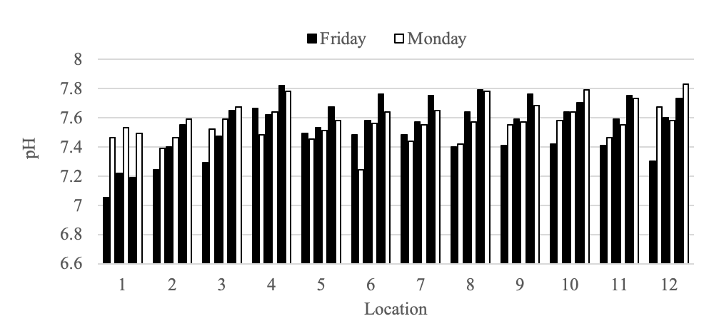
Figure SI-A: pH levels detected at each location (locations 1-12) on the six days of sampling. Fridays (black) and the following Mondays (white) are presented in order. The first bar is sampling event 1 (black), then 2 (white), and so on. Location descriptions can be found in Table 1, and sample events are described in Table 2

Figure SI-B: Measured residual chlorine versus hours stagnant at the individual taps, for locations 2-12. Hours stagnant are estimated from recorded use data, with 60 hrs remaining constant Monday sampling events (last sampled Friday evening). Symbols categorize floor (color) and riser (shape). Full location descriptions can be found in Table 1.

Figure SI-C: Total cell concentration versus hours stagnant at the individual taps, for locations 2-12. Hours stagnant are estimated from recorded use data, with 60 hrs remaining constant Monday sampling events (last sampled Friday evening). Symbols categorize floor (color) and riser (shape). Full location descriptions can be found in Table 1.

Figure SI-D: Copper concentration versus hours each fixture was stagnant, for locations 2-12. Hours stagnant are estimated from recorded use data, with 60 hrs remaining constant Monday sampling events (last sampled Friday evening). Symbols categorize floor (color) and riser (shape). Full location descriptions can be found in Table 1.

