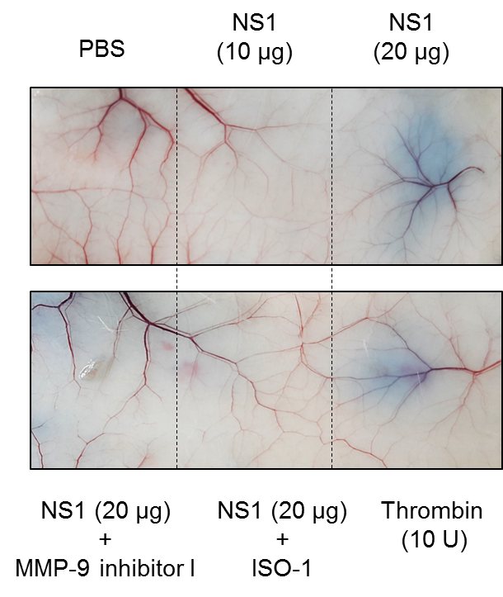
S9 Fig. Inhibition of MIF and MMP-9 attenuated NS1-induced vascular leakage in mice. BALB/c mice were intravenously injected with Evans Blue dye, followed by the subcutaneous injection of PBS or different doses of NS1, NS1 with MMP-9 inhibitor I or NS1 with ISO-1 for 6 h. After 5 h, the mice were subcutaneously injected with thrombin as a positive control. After another hour, the mice were sacrificed, and skin samples were collected and processed.

