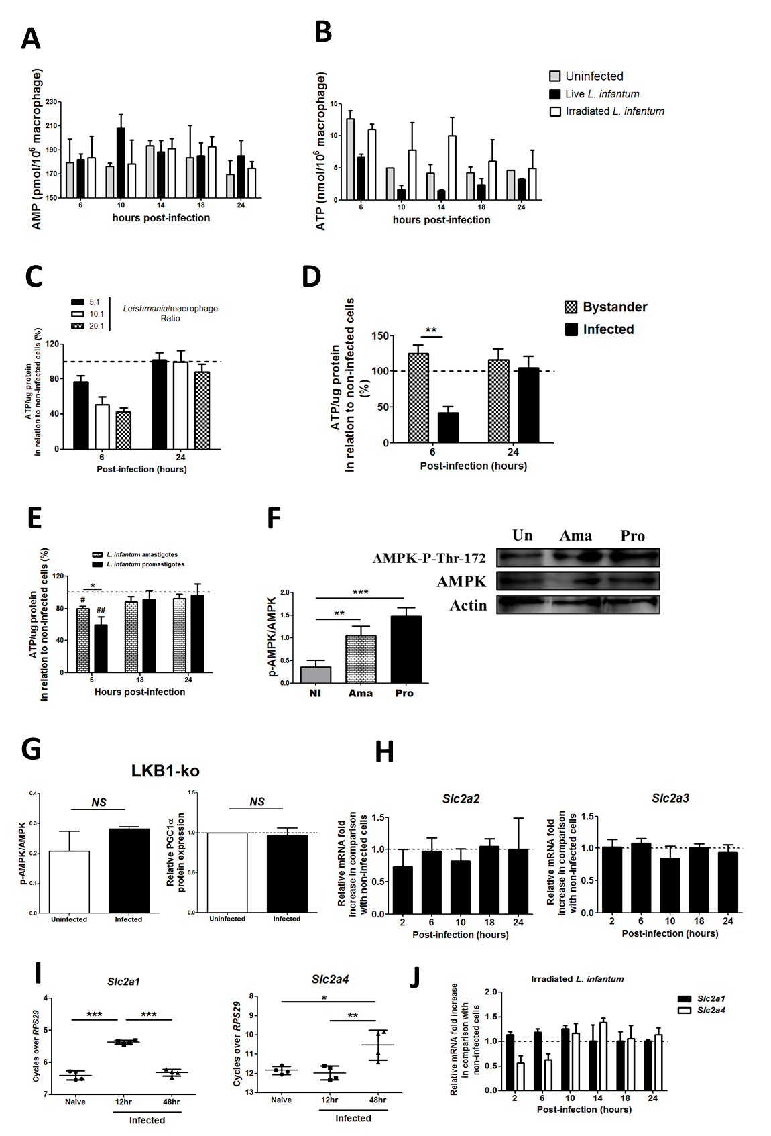

S5 Fig. Energetic and glycolytic fluctuations during L. infantum infection.
BMMo were infected with live and irradiated L. infantum (1:10 ratio). At different time points of infection AMP (A) and ATP (B) absolute levels were determined. Total ATP levels were determined in cells infected at different parasite doses (C) or in sorted infected and bystander cells (D). BMMo were infected with live axenic L. infantum amastigotes or promastigotes and the total levels of ATP were determined (E). At 10 hours post-infection, the levels of AMPK-P-Thr172 and AMPK were quantified. Graphic represents the corresponding densitometry analysis. Means ± SD are from two independent experiments (F). The levels of AMPK-P-Thr172, AMPK and PGC-1α were similarly quantified in uninfected and L. infantum infected BMMo recovered from LKB1-KO 14 hours p.i.. Graphic represents the corresponding densitometry analysis Means ± SD are from two independent experiments (G). The transcription levels of GLUTS were analyzed by qPCR. Slc2a2 and Slc2a3 transcripts from WT infected BMMo (H), Slc2a1 and Slc2a4 from naïve, L .infantum infected splenic macrophages (I) and irradiated L. infantum BMMo (J). Means ± SD are from three independent experiments. (*p <0.05, **p <0.001, ***p <0.0001). Significant differences related to uninfected BMMo (#p <0.05, ##p <0.001).

