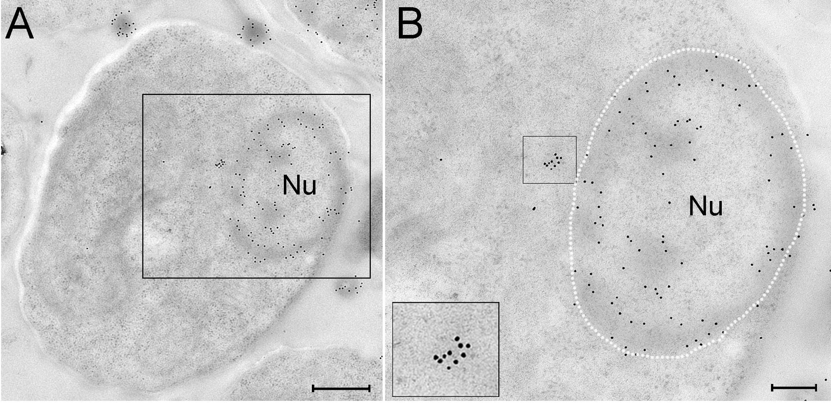
Figure S1: General DNA Immunolabling of PBCV-1 Infected Chlorella Cells.
A, B. PBCV-1-infected cells were cryo-immobilized using HPF-FS and thin sections were immuno-labeled with anti-DNA antibodies. A. Low magnification view of a 2-6 PI infected cell. B. High magnification of the region in panel A. Note the clustered DNA labeling that implies a condensed conformation of the viral DNA near the nucleus. Inset: high magnification of the apparently viral DNA (nucleus borders are delineated with a white dashed line). Nu: nucleus. Scale bars: A: 500 nm; B: 200 nm.

