S2 Text: Gating strategies and flow cytometry data not presented in the main text

The representative gating strategy in the spinal cord
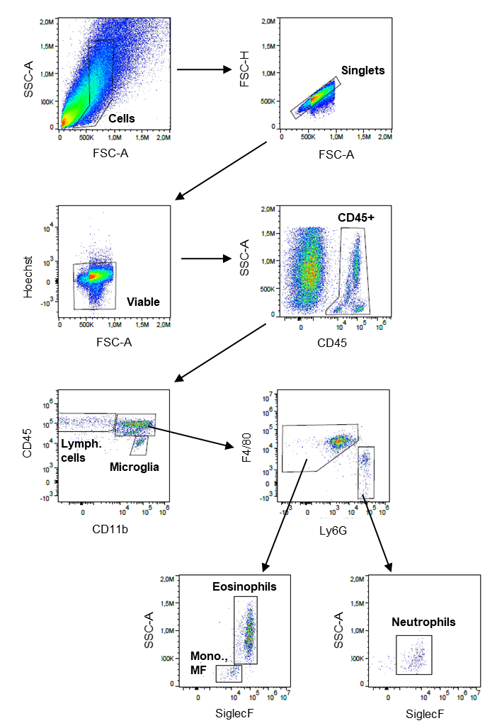

The representative gating strategy in the brain stem
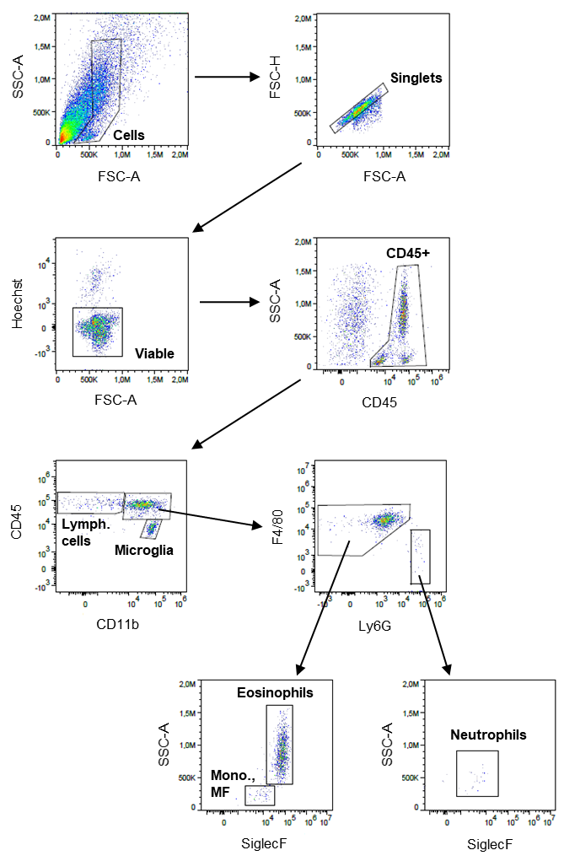

The representative gating strategy in the cerebellum
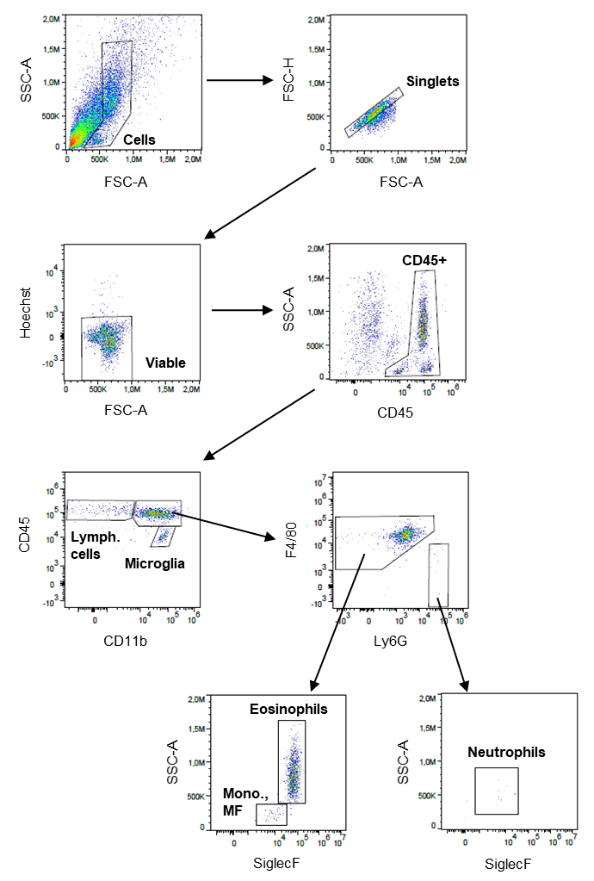

The representative gating strategy in the hemisphere, fluorescence minus one (FMO) or isotypes controls are also depicted
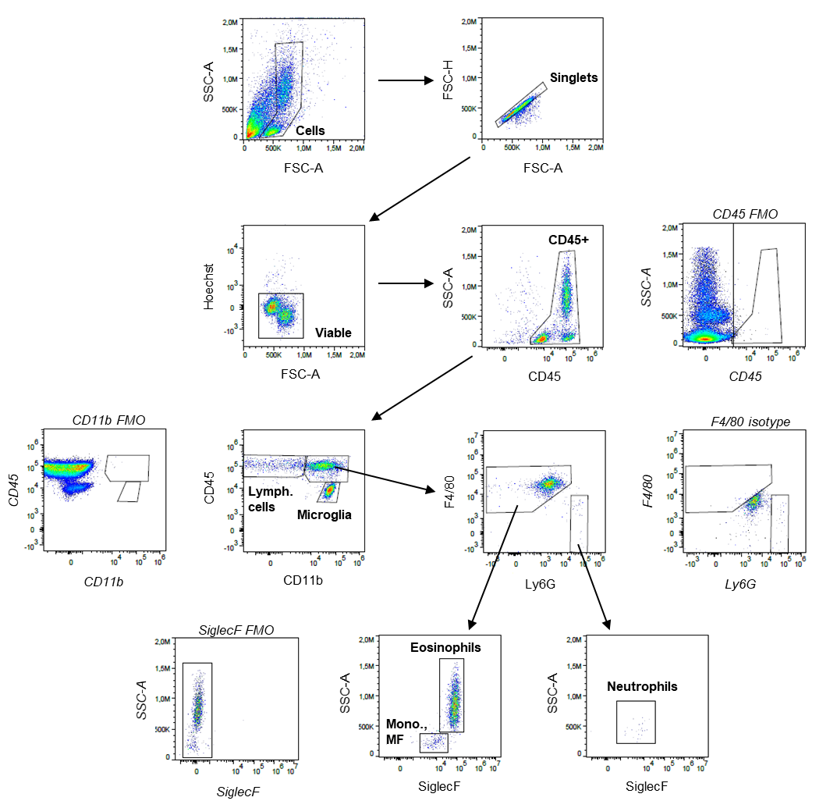

The comparison of immune cells in the CNS of 9- and 12-week old naïve mice (age-matched to infected mice 7 and 28 dpi)
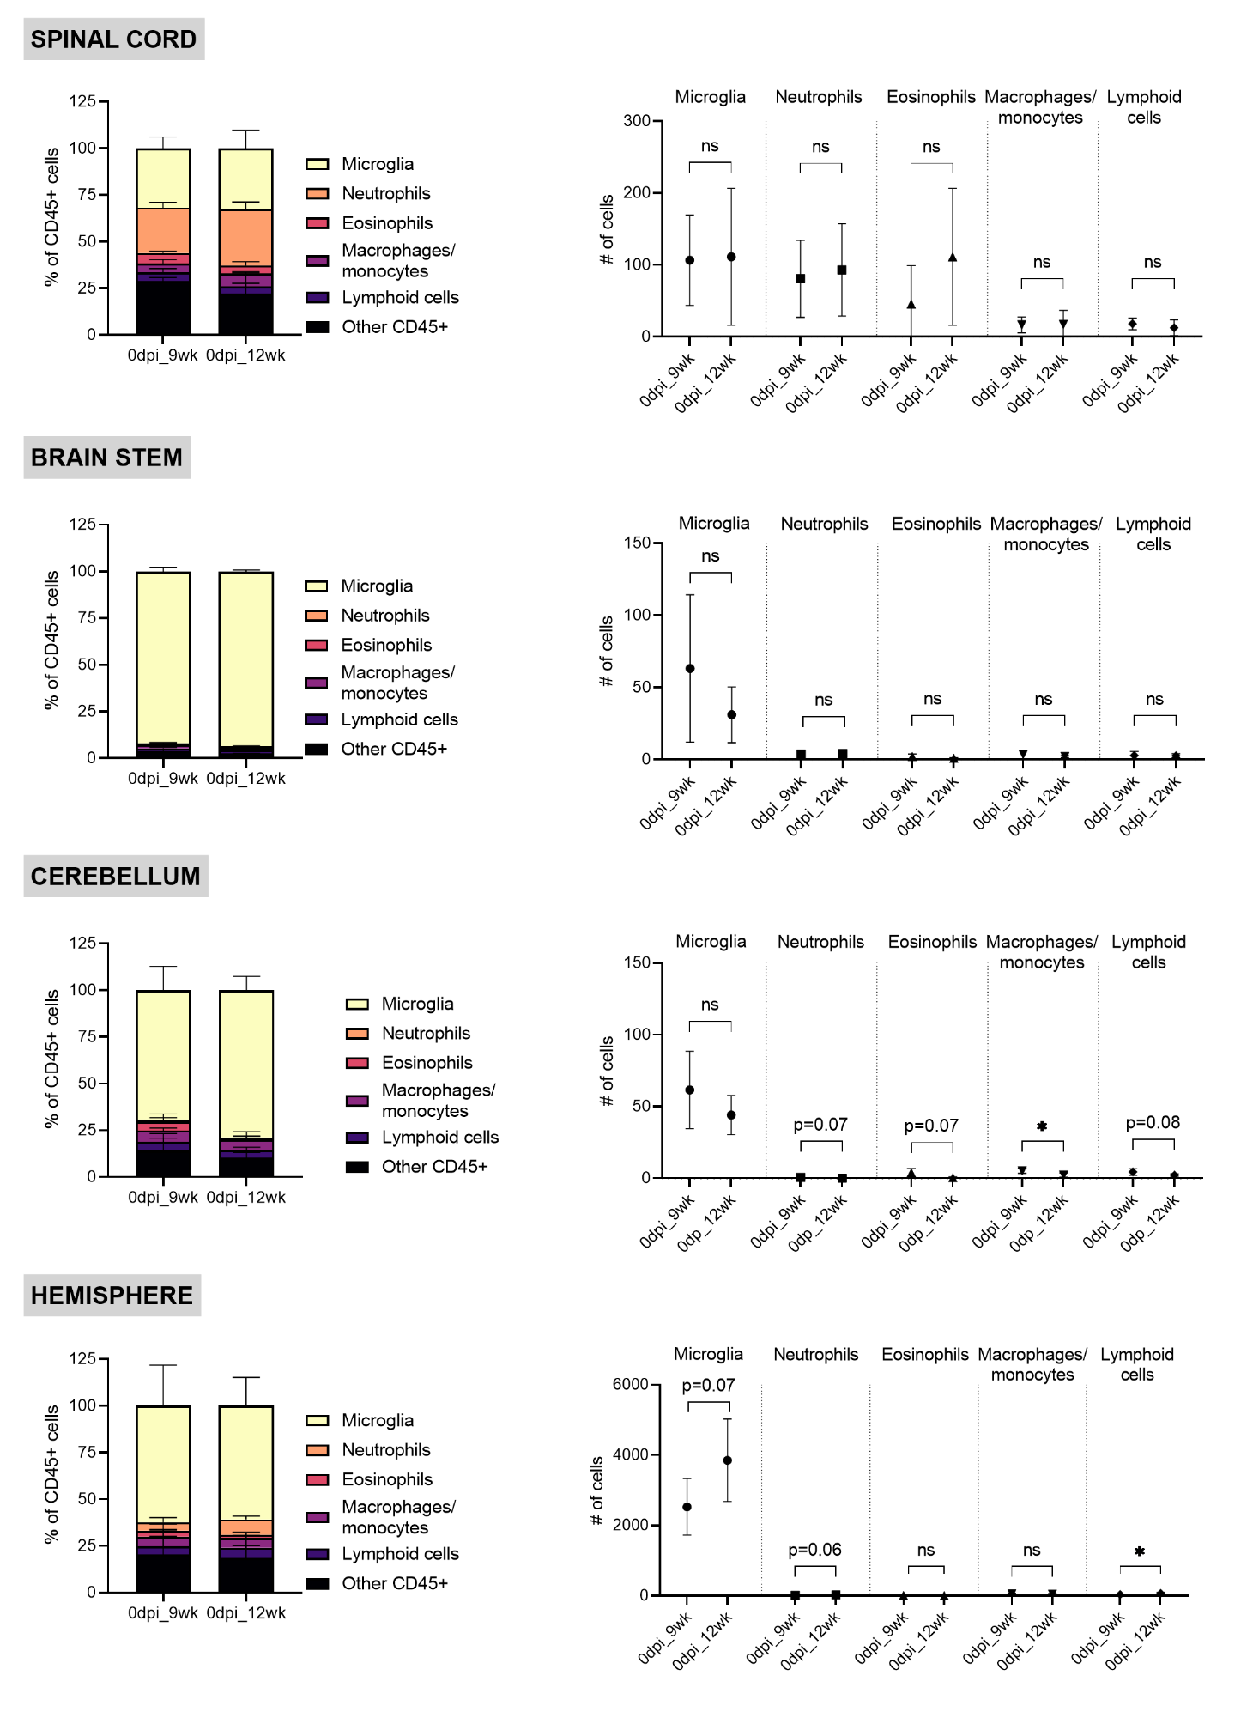
The representative gating strategy in the blood
