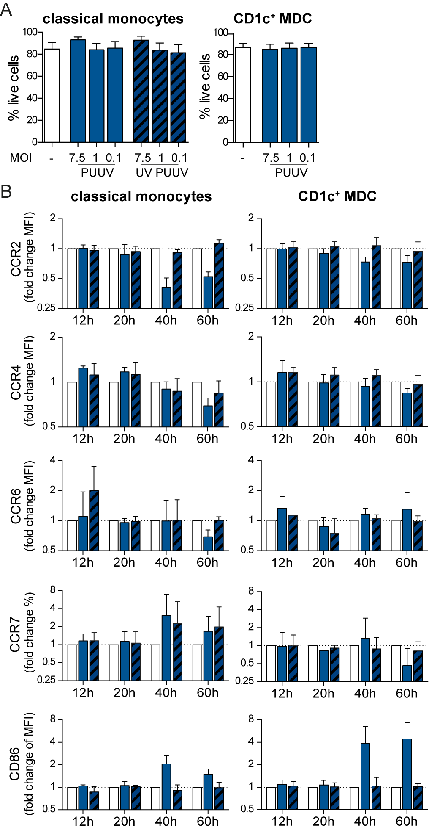

Figure S6. Dynamic changes in expression of chemokine receptors on classical monocytes and CD1c⁺ MDCs upon exposure to PUUV in vitro. (A) Human CM and CD1c⁺ MDCs were isolated from peripheral blood of healthy volunteers. Cells were left unexposed (white), exposed to PUUV (ocean blue) or UV PUUV (patterned ocean blue) for 2 hours at an MOI of 7.5, 1 or 0.1. Excess viruses were removed and cells were subsequently infected for 12-60 hours. Viability of cells at 24 hours was assessed by flow cytometry based on a LIVE/DEAD dye. Graphs show mean±SD viability of CM (left panel, n=3) or CD1c⁺ MDC (right panel, n=3). (B) Bar graphs summarize the MFI±SD of CCR2, CCR4, CCR6, CCR7 and CD86 (n=4-6).

