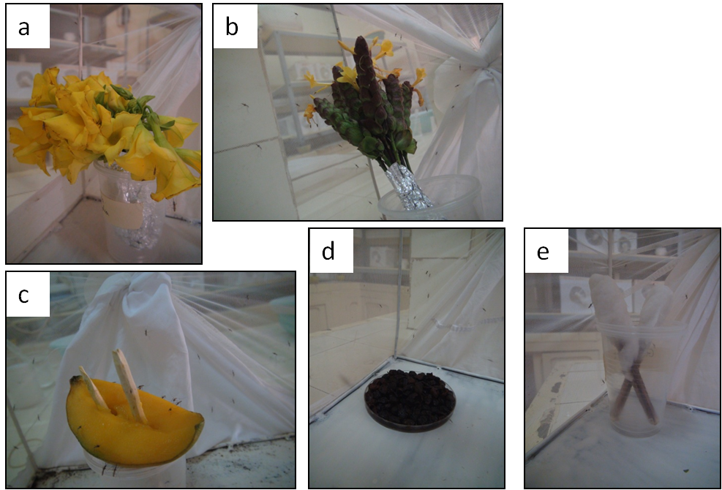
S2 Figure: Sugar treatment layout. (a) Bundle of flowers of Thevetia neriifolia. (b) Bundle of flowers of Barleria lupilina. (c) Fruit of Mangifera indica. (d) Fruits of Lannea. microcarpa microcarpa. (e) 5% glucose solution on cotton pads.

