S3 Fig
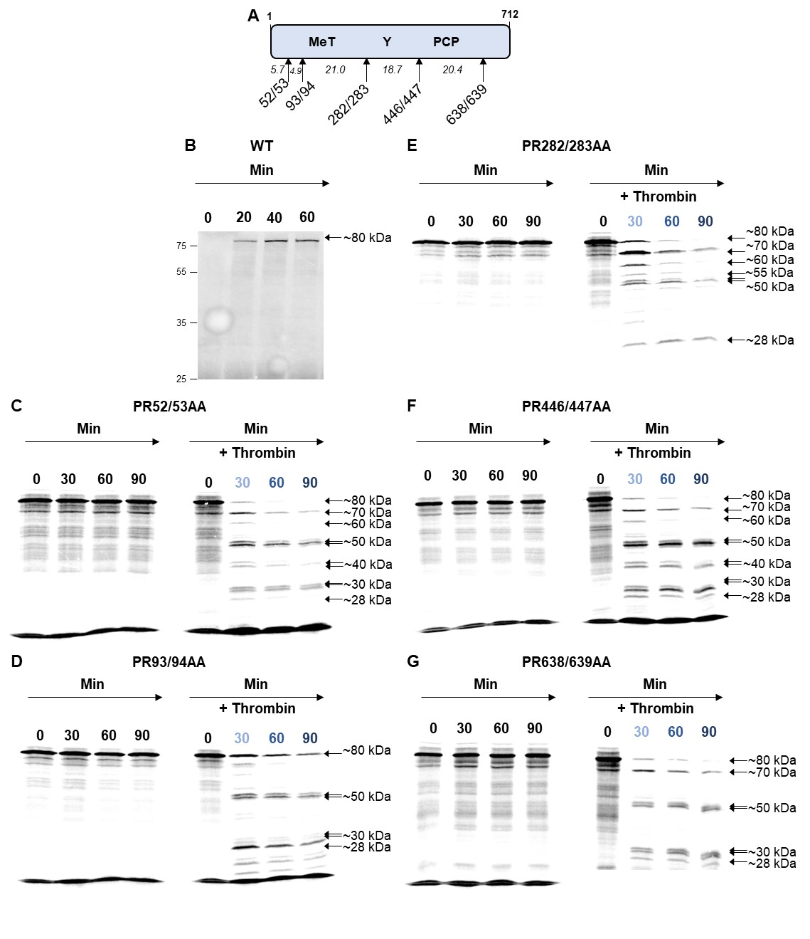
Figure S3. Thrombin proteolysis of the N-terminal portion of pORF1. (A) Schematic of the truncated pORF1 expression plasmid. (B) A plasmid expressing the N-terminal portion of the WT pORF1 polyprotein were used to template in vitro coupled transcription/translation reactions labelled with [³⁵S] methionine. (C-G) Plasmid expressing amino acids 1-712 of pORF1 with the indicated alanine substitutions at amino acids (C) PR52/53, (D) PR93/94, (E) PR282/283, (F) PR446/447, (G) PR638/639, before being used to template [³⁵S] methionine labelled in vitro coupled transcription/translation reactions. Where indicated to duplicate reactions a zero minute sample was taken before the addition of 0.5 IU of thrombin followed by collection of protein samples at the indicated time-points representing minutes after the addition of thrombin. Samples were harvested into Laemmli buffer to stop reactions, proteins separated by SDS-PAGE and visualised by autoradiography and phosphorimaging. The approximate molecular weight of each product is indicated together with the molecular weight ladder on the left of the gel (n = 2 +/- SD).

