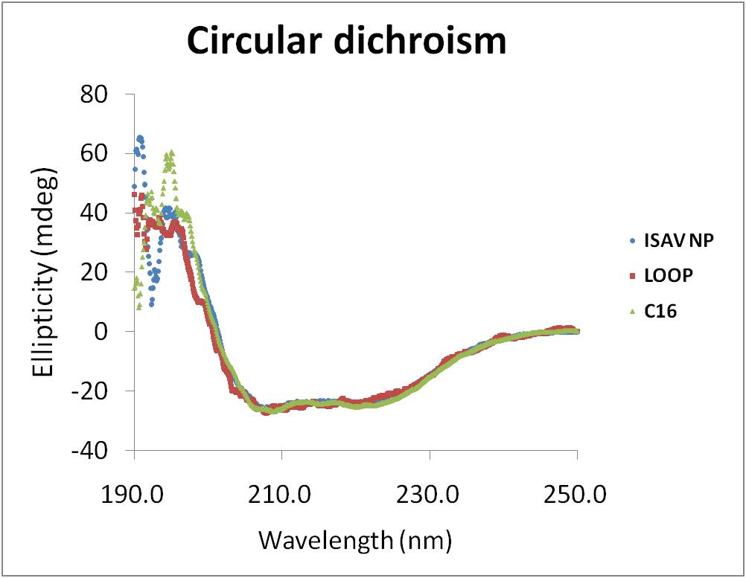

Figure S5. Far-UV CD Spectra of ISAV NP. All three NP proteins, including the wt NP (blue), ΔLOOP (red) and ΔC16 (green) were kept at 5 μM concentration. Protein buffer was 200 mM potassium phosphate pH 7.5. Measurements were done at room temperature.

