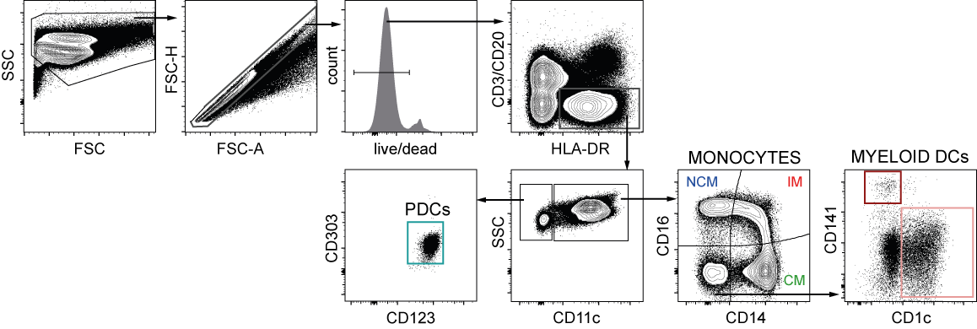

Figure S2. Identification of DC subsets and monocytes in PBMCs from HFRS patients and uninfected controls. Gating strategy used to identify monocytes as well as MDC and PDC subsets within the live Lin⁻ HLA-DR⁺ fraction in blood PBMCs.

