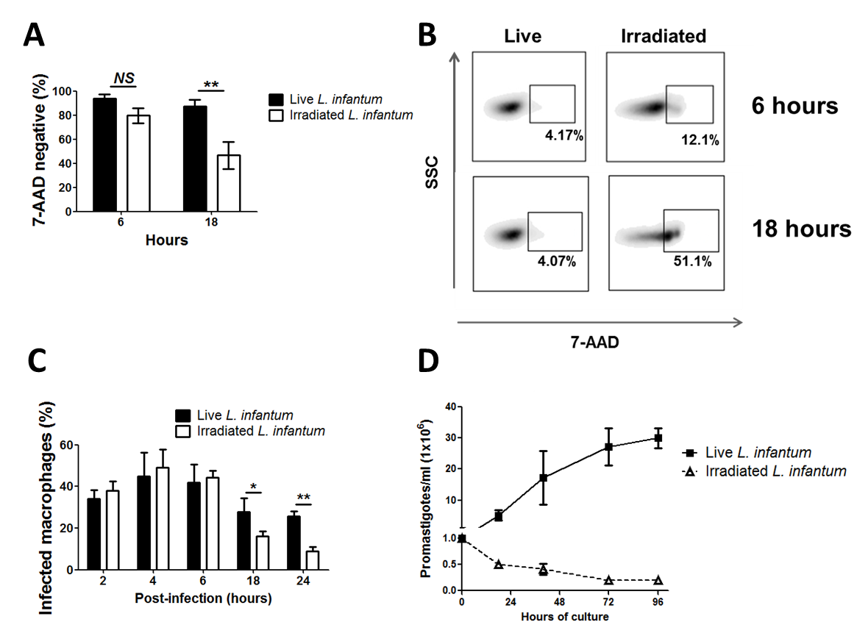

S2 Fig. Profile of irradiated L. infantum promastigotes.
L. infantum promastigotes were irradiated to 3000 Gy. (A) The viability of irradiated and non-irradiated parasites (live; corresponding to the same batch of parasites) was determined by 7-AAD staining in flow cytometry. (B) One representative example at 6 and 18 hours after the irradiation is depicted. BMMo were infected with live or irradiated L. infantum promastigotes (immediately after irradiation). (C) The percentage of infected macrophages was quantified until 24 hours pi. (D) Live and irradiated parasites were cultured at 1 x 10⁶ parasite/ml and followed during four days. The culture density was quantified at a daily basis. One representative experiment is shown from three independent experiments. (NS – non significant; *p <0.05; **p<0.01).

