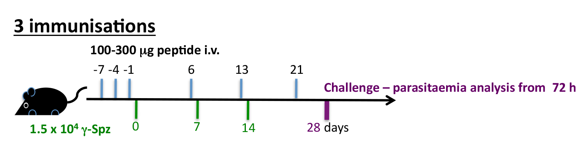

 | No. protected/  No. challenged  (%) | Prepatency  (in days)
Sham tolerised | 12/12  (100) | -
PbS20₃₁₈ tolerised | 6/6  (100) | -
PbTRAP₁₃₀ tolerised | 12/12  (100) | -
Naïve challenged | 0/9  (0) | 3

Table S3

