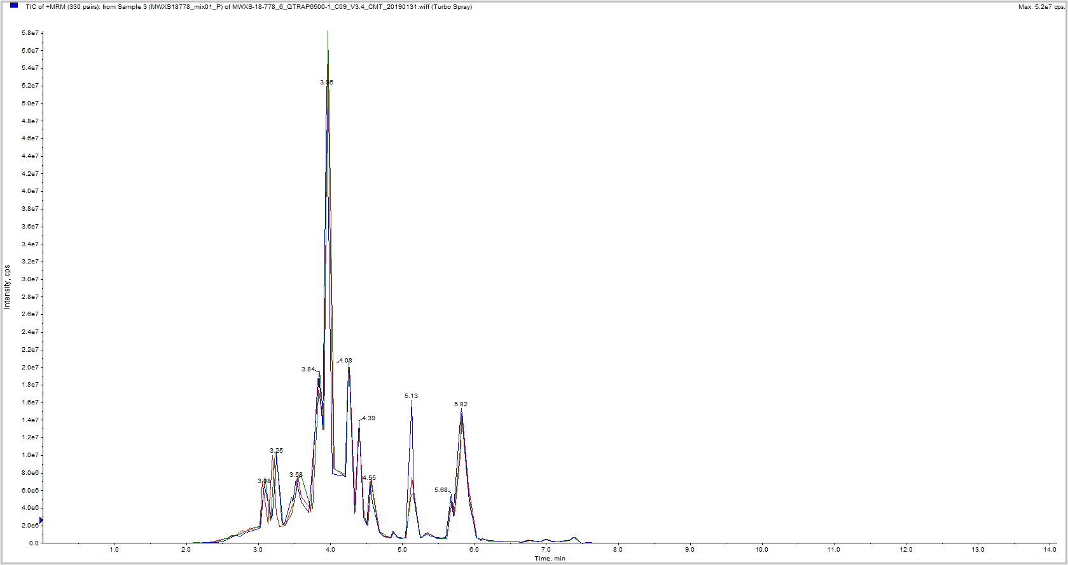
S6 Fig: Typical total ion current chromatograms (TIC) of all samples.

