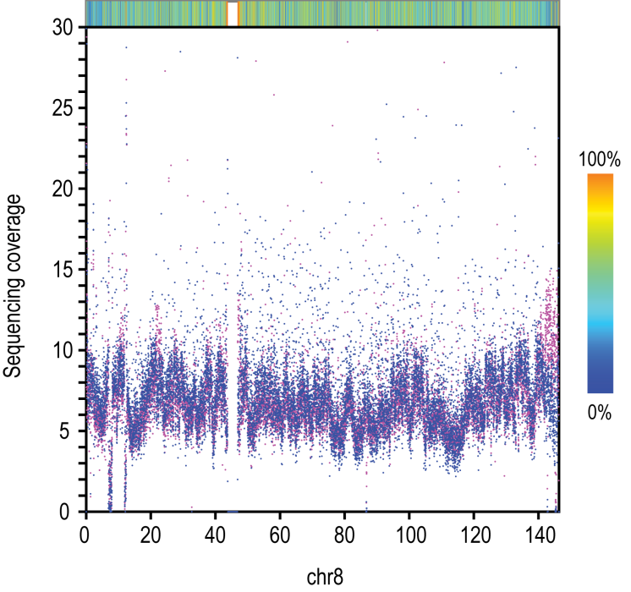
Figure S1 Sequence-depth coverage on chromosome 8 of standard small insert PE reads (blue dots) and long-range PE reads (red dots).Sequence depth was calculated in 10 kb-window for a total of ~7-fold combined sequencing data from long-range PE libraries (except the 10 kb-dam and 10 kb-WGA data) and ~7-fold sequencing data from standard small-insert libraries.

