S5 Fig. KCCQ score: non-TF TAVI versus SAVR (operable at a high risk)
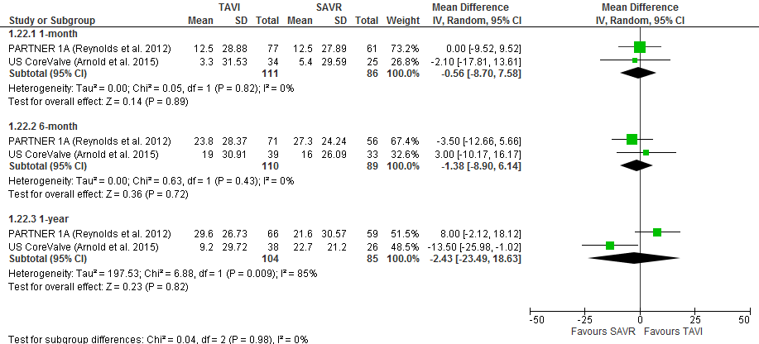
Legend: For TAVI the route was transapical in the PARTNER 1A trial and non-transfemoral in the US CoreValve trial. Standard deviations were calculated for the meta-analysis by the authors of the current review. KCCQ, Kansas City Cardiomyopathy Questionnaire; Non-TF, non-transfemoral.

