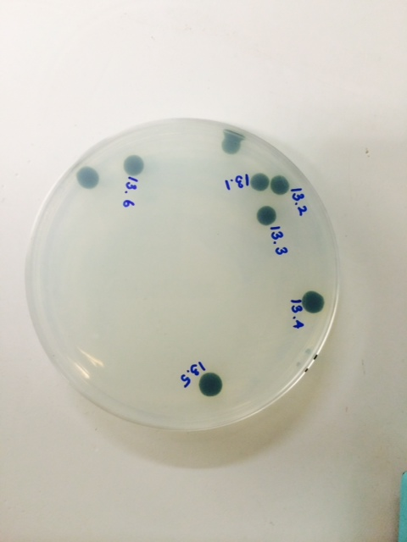

S1 Fig. Agar-grown samples in the light. The microalgal cells form colonies. RNA seq analysis was performed on the colonies that were numbered.

