Supplemental Figure 1. Density plots
Dotted line indicates data split point

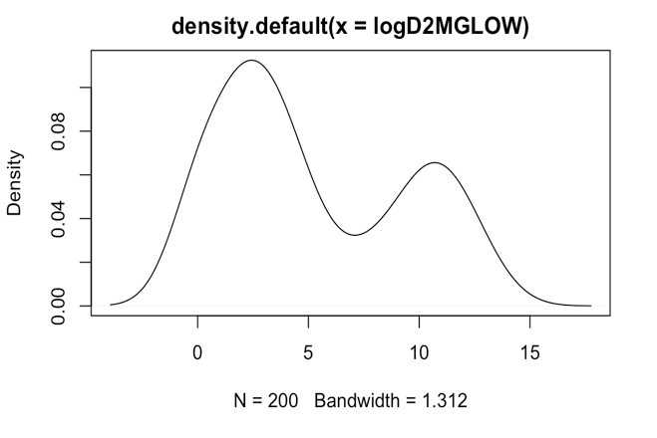
DENV-1 MG LOW DENV-2 MG LOW
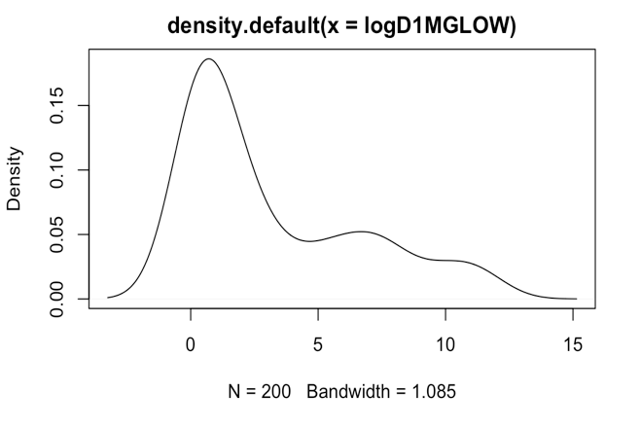
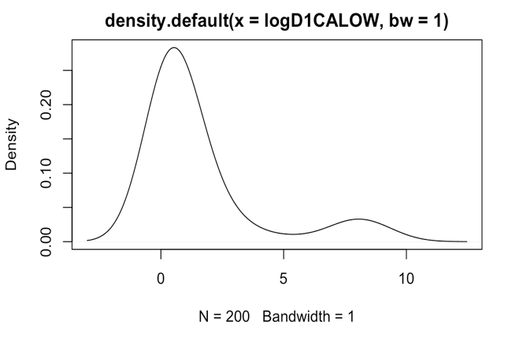
DENV-1 CA LOW DENV-2 CA LOW
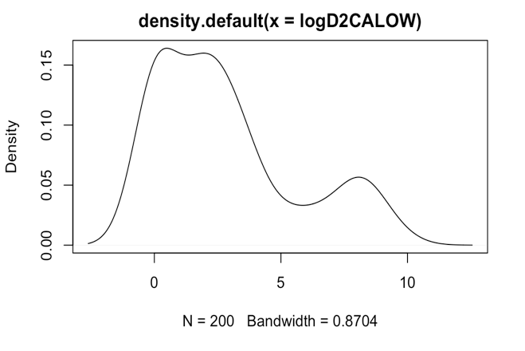

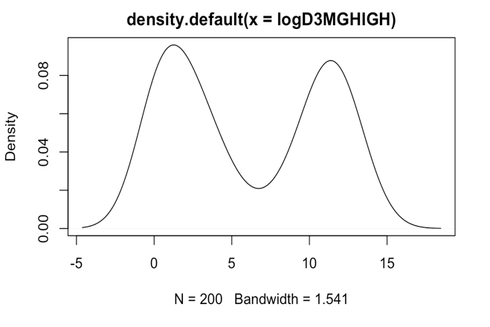
DENV-3 MG HIGH DENV-4 MG HIGH
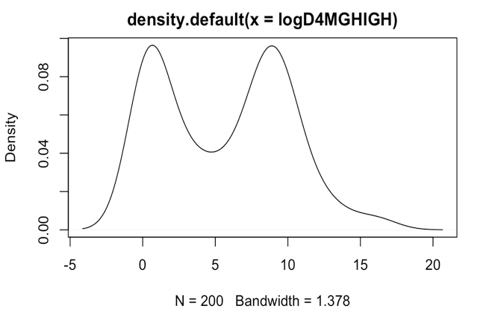

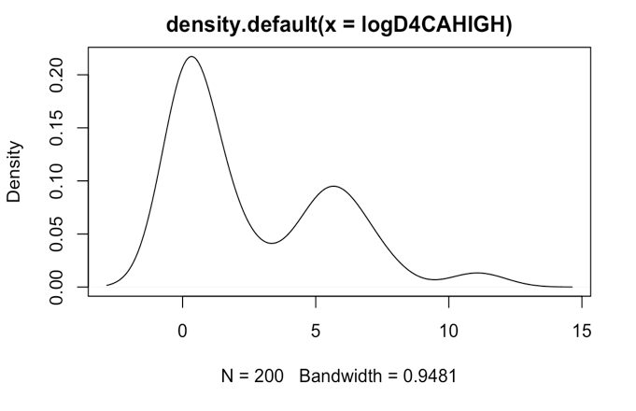
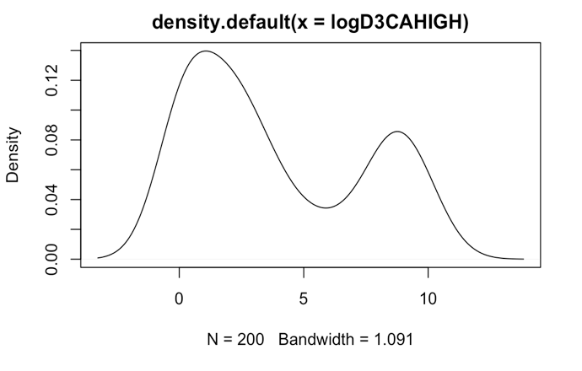
DENV-3 CA HIGH DENV-4 CA HIGH
DENV-1 CA HIGH DENV-2 CA HIGH
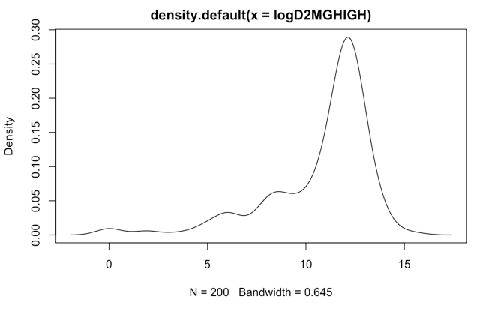
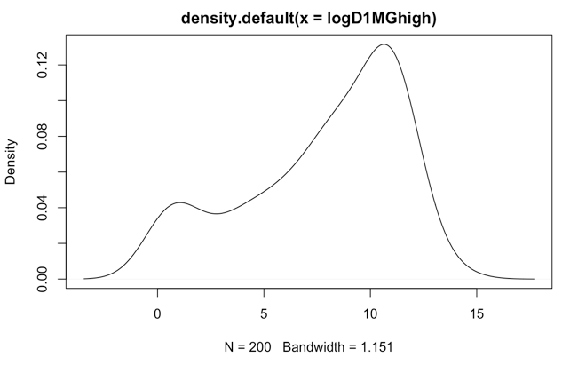

DENV-1 MG HIGH DENV-2 MG HIGH
