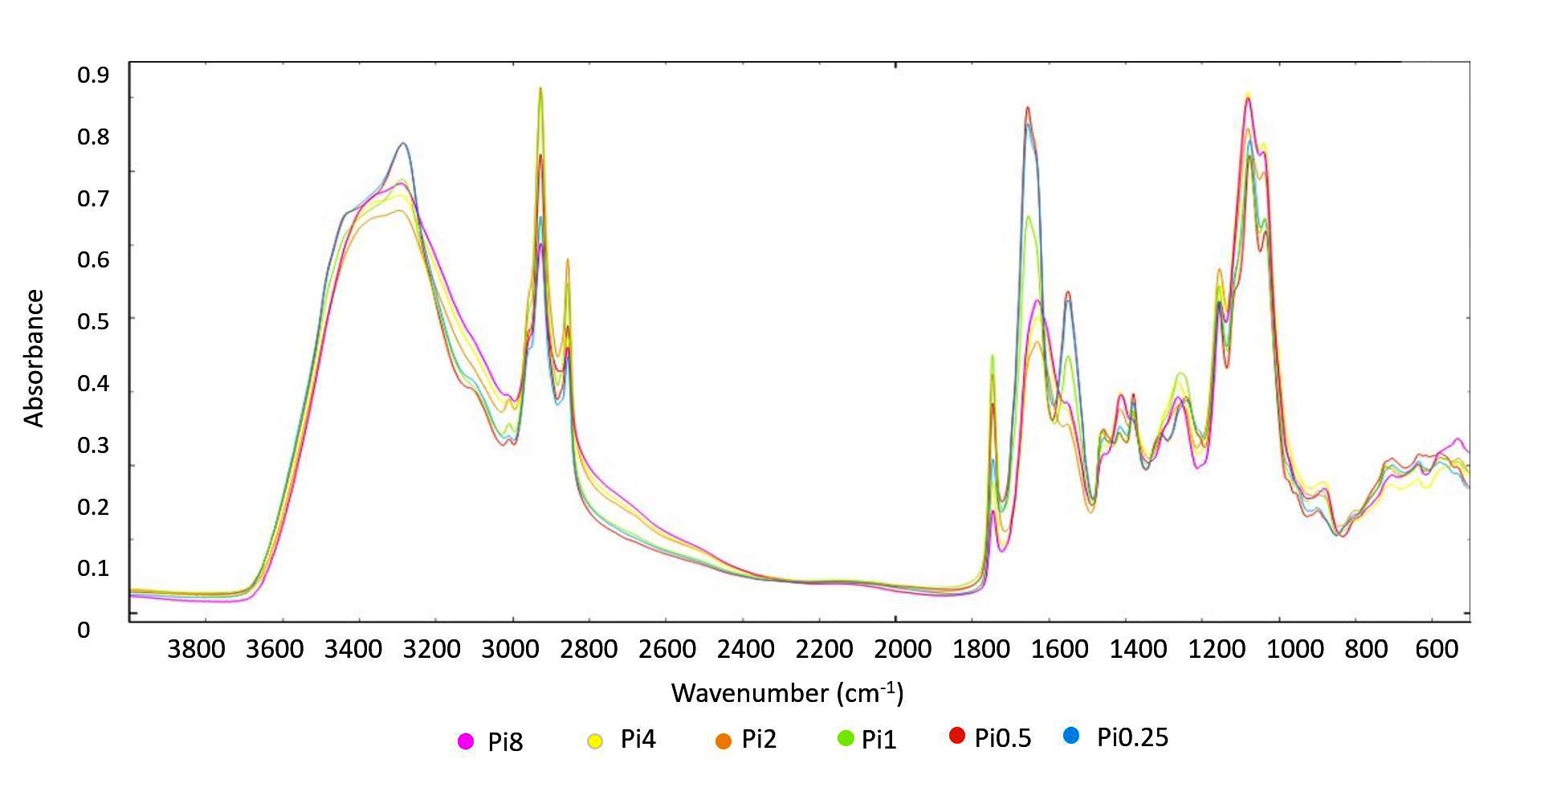
Supplementary Figure 7. FTIR-HTS spectra of Lichtheimia corymbifera (EMSC corrected); ammonium sulphate nitrogen source, different Pi-levels

