A
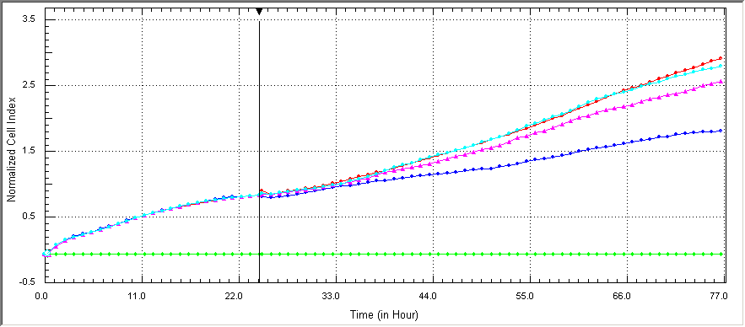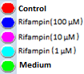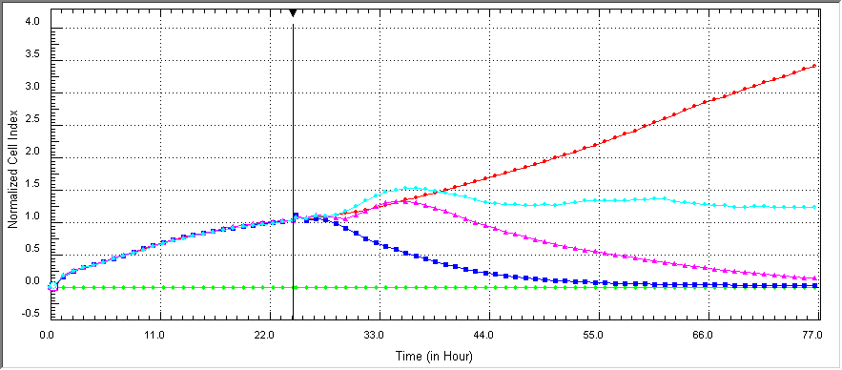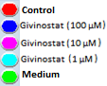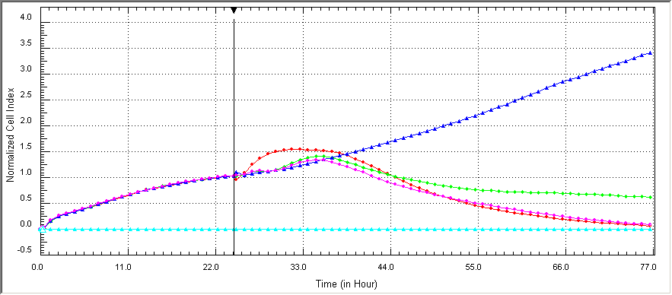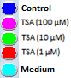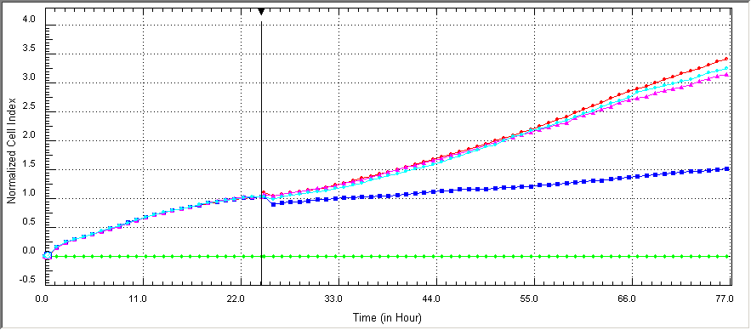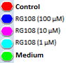
B
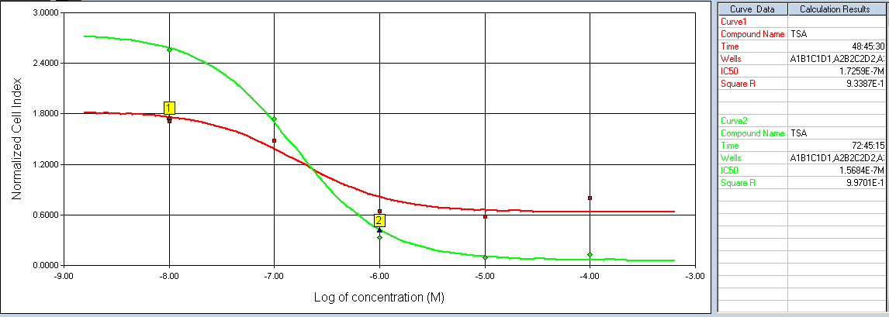
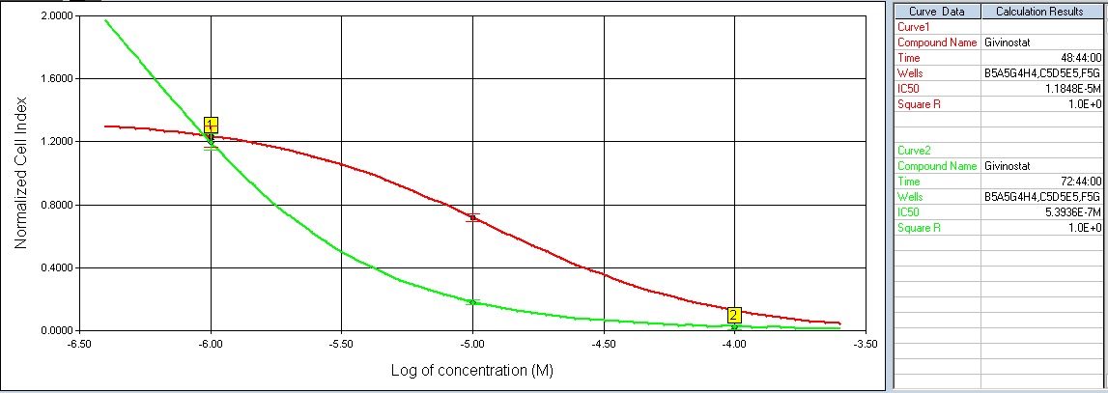
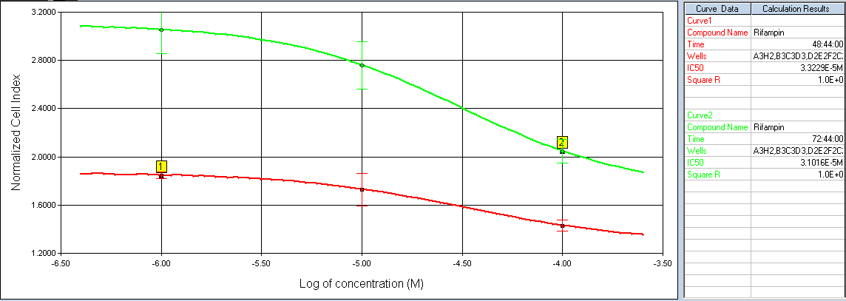
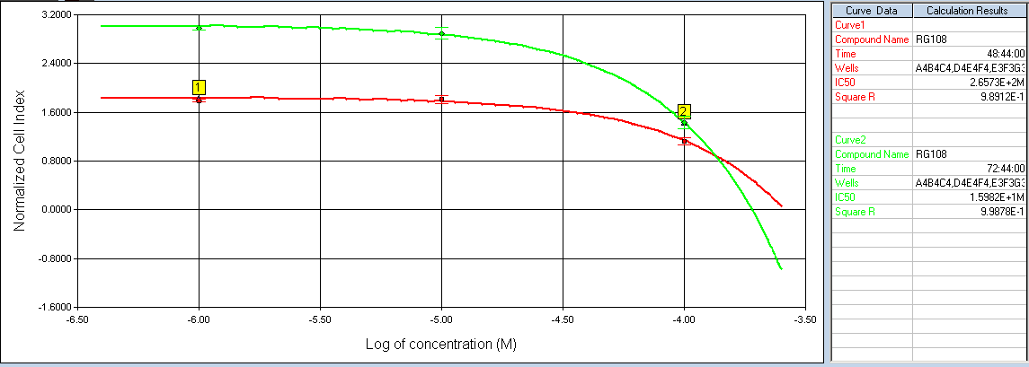
S2 Fig. Cell proliferation analysis results of HMC3 cells. A: Real-time monitoring of the effects of treatment groups on HMC3 cell viability for 48 hours using the xCELLigence instrument. The CI values were recorded every 1 h with the instrument, which appeared as each dot on the graph based on the electrical impedance. B: IC₅₀ values of HMC3 cells. Cells were treated with 1, 10 and 100 µM TSA, givinostat, rifampin, and RG108 concentrations and the IC₅₀ values were calculated according to the CI values at 24th (red) and 48th (green) hours in the analysis software of the instrument. Data was confirmed in three independent experiments, n=8 for each treatment group.

