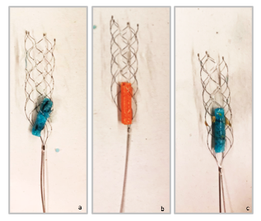

**S2 Fig (a-c).** **Retrieved clots with stent retriever.** Agarose-based clots mixed with 10% MCI/MI (a,c), with spiral (a) or barbed (c) supporting structures, and with 20% MCI/MI (b) were successfully retrieved with a clot extraction device (SolitaireTM 4mm x 20mm, Medtronic, Dublin, Ireland).