Supporting Information:

Table S1 Primers used in constructing procedure
Primer No. | Name | Sequence
1 | 304tH -F | 5’-CGGAATTCATGGTTTTAACCAATAAAACA-3’
2 | 304tH-R | 5’-GTTCTGCAGTTAGGATTTAATGCAGGTGA-3’
3 | 304T3-F | 5’-CTTGGGCCCATAAAAAACACGCTTTTTCAG-3’
4 | 304T3-R | 5’-CGGAATTCTTGTTTGTTTATGTGTGTTTAT-3’
5 | 304Ct-F | 5’-GTTCTGCAGATTAGTTATGTCACGCTTACATTCA-3’
6 | 304Ct-R | 5’-CGGGATCCAGCTTGCAAATTAAAGCCTT-3’
7 | 403E20-F | 5’-CGGGATCCATGGCTTCAGAAAAAGAAATTA-3’
8 | 403E20-R | 5’-CGGAATTCCTATTTGCTTCTCTTGTAAAC-3’
9 | 403T3-F | 5’-GCTCTAGAATAAAAAACACGCTTTTTCAG-3’
10 | 403T3-R | 5’-CGGGATCCTTGTTTGTTTATGTGTGTTTAT-3’
11 | 403Ct-F | 5’-CGGAATTCATTAGTTATGTCACGCTTACATTCA-3’
12 | 403Ct-R | 5’-CGGGGCCCAGCTTGCAAATTAAAGCCTT-3’
13 | BTS-F | 5’-ATGGAGGCCAAGATAGATGA-3’
14 | BTS-R | 5’-TCACAATTCGGATAAGTGGT-3’
15 | 425T3-F | 5’-TCGAGCTCATAAAAAACACGCTTTTTCAG-3
16 | 425T3-R | 5’-TTGTTTGTTTATGTGTGTTTATTTGAAAGATAATTGTGCCAT-3’
17 | TS-F | 5’-ATGGCACAATTATCTTTCAATGCC-3’
18 | TS-R | 5’-TTCAATTCAATTCAATTTATTAAACTTGGATAGGGTC-3’
19 | 425Pt-F | 5’-TAAATTGAATTGAATTGAAAT-3’
20 | 425Pt-R | 5’-AACGAACGCAGAATTTTCG-3’
21 | btP1-F | 5’-CCAAGCTTTATTTTAGATTCCTGACTTCAAC-3’
22 | btP1-R | 5’-TCATCTATCTTGGCCTCCATTGTTTTATATTTGTTGTAAA-3’
23 | OEBTS-F | 5’-ATGGAGGCCAAGATAGATGAG-3’
24 | OEBTS-R | 5’-TCACAATTCGGATAAGTGTCACAATTCGGATAAGTG-3’
25 | btCt-F | 5’-ATTAGTTATGTCACGCTTAC-3’
26 | btCt-R | 5’-TTGGGCCCAGCTTGCAAATTAAAGCCTT-3’
27 | crP1-F | 5’-CCAAGCTTTATTTTAGATTCCTGACTTCAAC-3’
28 | crP1-R | 5’-CCTTAGAACCAGAAACCATTGTTTTATATTTGTTGTAAA-3’
29 | crtE-F | 5’-ATGGTTTCTGGTTCTAAGGCTG-3’
30 | crtE-R | 5’-TCACAATTCGGATAAGTGTTAAGCTATCTTCATGACA-3’
31 | crCt-F | 5’-ATTAGTTATGTCACGCTTAC-3’
32 | crCt-R | 5’-CTTGGGCCCAGCTTGCAAATTAAAGCCTT-3’
33 | gpP1-F | 5’-CCAAGCTTTATTTTAGATTCCTGACTTCAAC-3’
34 | pgP1-R | 5’-GCCATTGCGGTATAAGCCATTGTTTTATATTTGTTGTAAA-3’
35 | GPbc-F | 5’-ATGGCTTATACCGCAATGGCAGC-3’
36 | GPbc-R | 5’-TCACAATTCGGATAAGTGTTAGTTTTGCCTGAAAGCG-3’
37 | gpCt-F | 5’-ATTAGTTATGTCACGCTTAC-3’
38 | gpCt-R | 5’-CTTGGGCCCAGCTTGCAAATTAAAGCCTT-3’

Table S2. Homology modeling templates information
Enzyme | Template PDB code | Total score | Query coverage | E-value | Identity
GGPPSbc | 2J1P | 381 | 73% | 1e⁻¹³⁰ | 65%
GGPPSgb | 3KRA | 421 | 75% | 3e⁻¹⁴⁶ | 69%
GGPPSrc | 2E90 | 541 | 98% | 0 | 86%
GGPPSeh | 3KRA | 124 | 65% | 7e⁻²² | 42%
GGPPScr | 3KRA | 400 | 84% | 1e⁻¹³⁸ | 65%
GGPPSsc* | 2DH4 | 679 | 100% | 0 | 100%
*The X-ray crystal structure of GGPPSsc has already been resolved and deposited in Protein Data Bank (code: 2DH4)

(a)
(b)
Fig. S1 (a) ¹H NMR spectra of taxadiene. 400MHz, CDCl3: 5.3(t,J=4.8 Hz,1H), 2.04-1.90 (m,14H), 1.61 (s,6H), 1.53 (s,9H); (b) ¹C NMR spectra of taxadiene. 100MHz, CDCl3: 124.40, 124.19, 123.79, 123.29, 59.40, 39.73, 39.70, 39.57, 26.77, 26.63, 26.33, 25.70, 17.69, 16.29, 16.02.

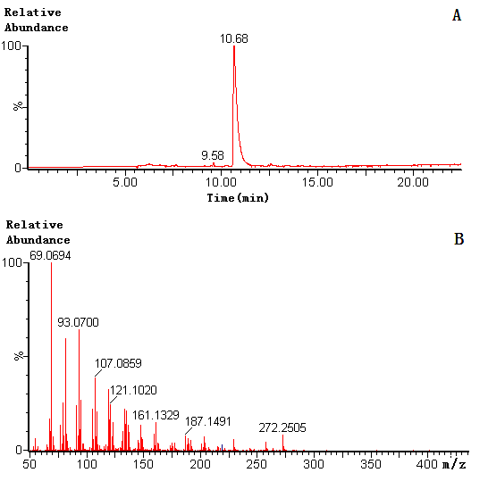
Fig. S2 Production of taxadiene by engineered S. cerevisiae. This strain was cultivated in SD medium with 2% glucose for 66hour. A: GC-MS analysis of n-Hexane extracts. B: Mass spectra of taxadiene.

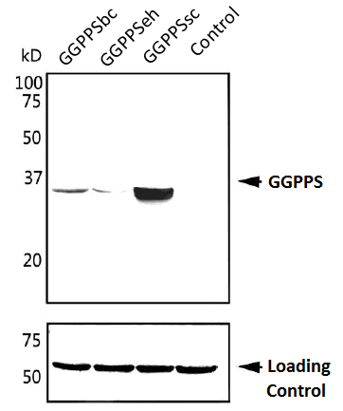
(a)

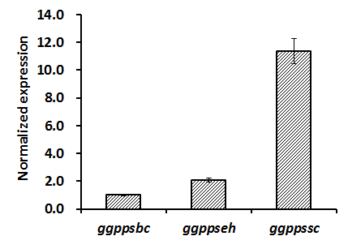
(b)
Fig. S3 (a) Western blotting of different GGPPS during exponential growth of yeast. (b) Relative expression of different ggpps analyzed by real-time PCR.

Fig. S4 Cell mass (OD₆₀₀) and taxadiene production of SyBE_001115 under different airflow rates.

