*Propsensity matching was performed using “MatchIt” package in R. Optimal matching technique was used.*

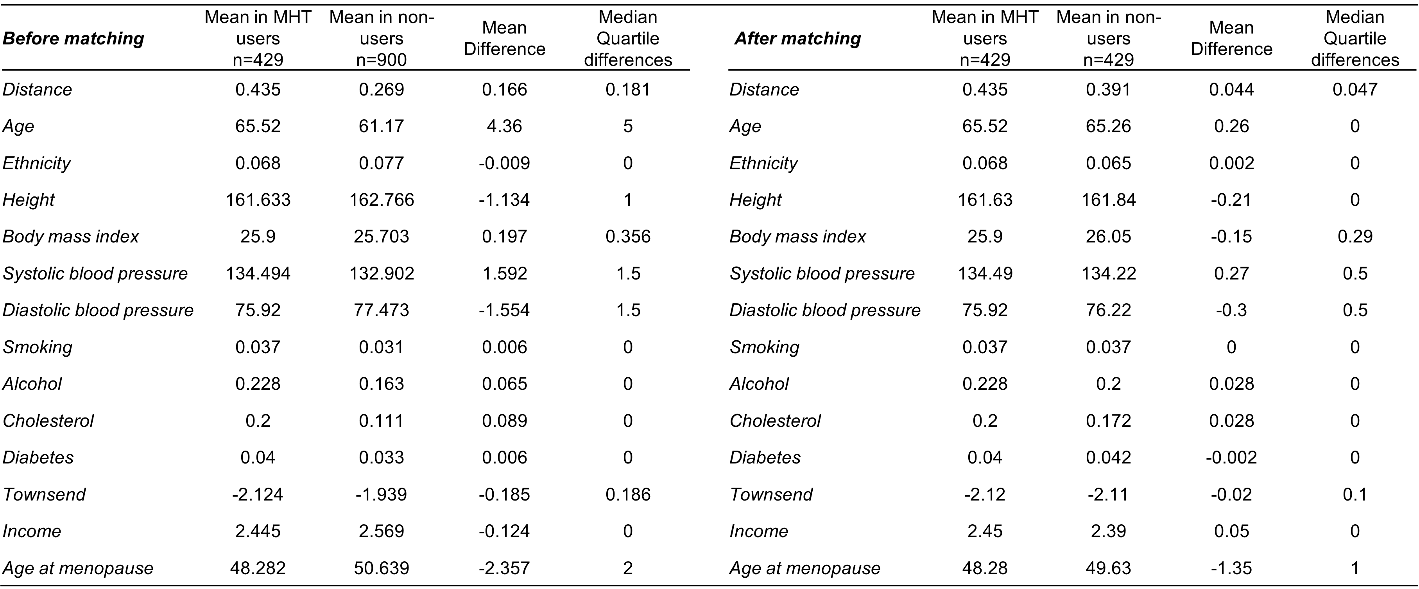

Supplementary Table 2: Co-variate balance before and after propensity-matching.