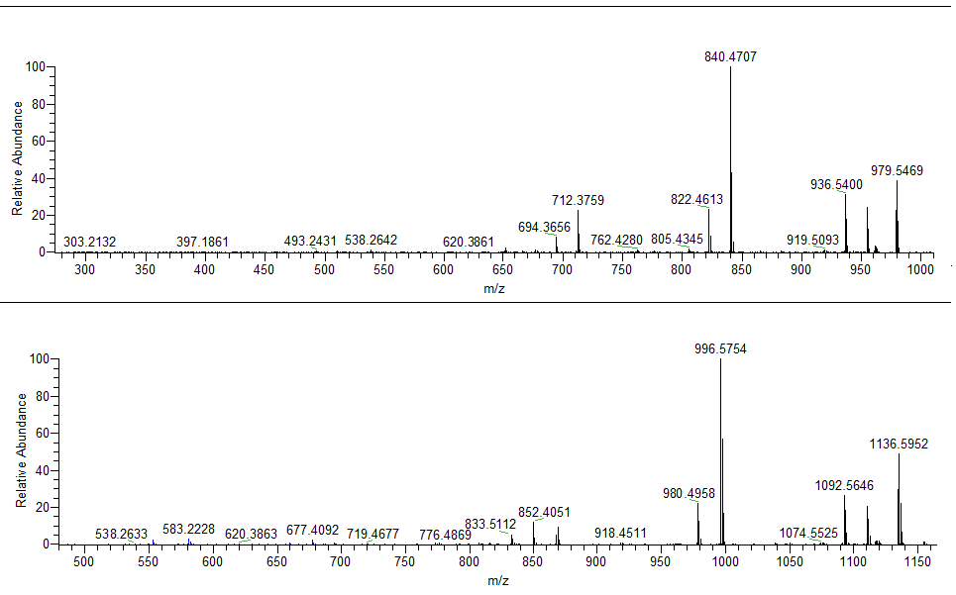

[M+H - 1,4NQ]+

y2

y5

b5

YGGFLRKR

Y°GGFLRKR

[M+H]+ – NH3

**B**

**A**

**[M+H]+ – H2O**

**b7**

**b4**

b6 + H2O

b7

b6

**b6**

b5

y6

b7 + H2O

y7