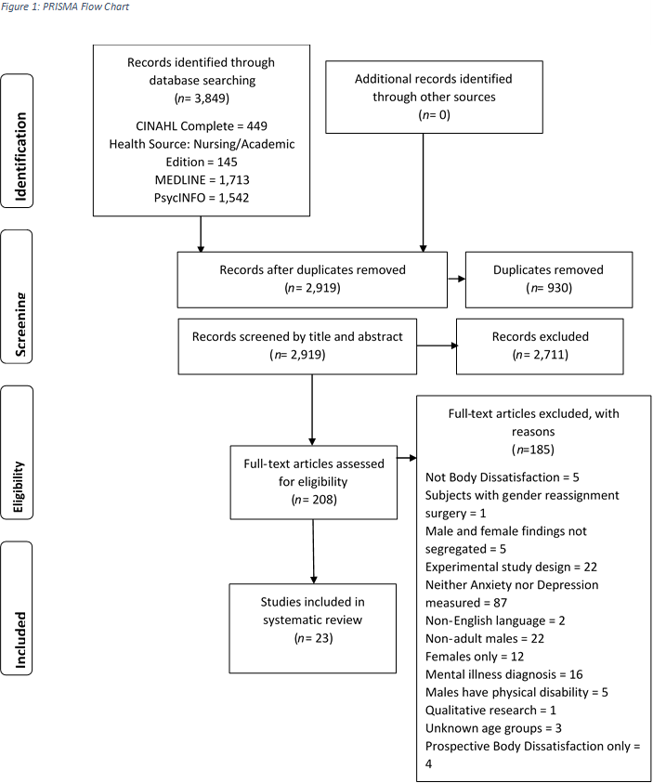

Studies included in content analysis

(*n*= 23)

Studies included in meta-analysis

(*n*= 18)