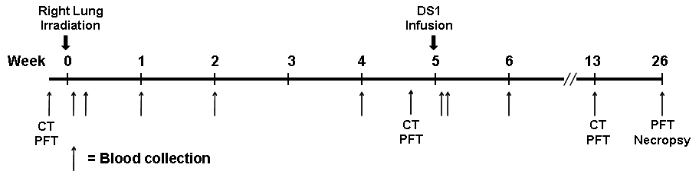

Figure S4. Schematic diagram of experimental design for lung irradiation and DS1 cell infusion.

