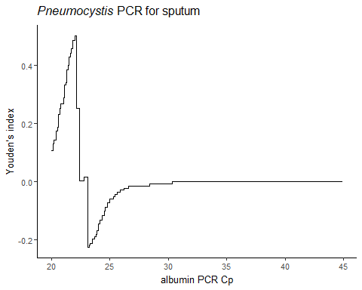 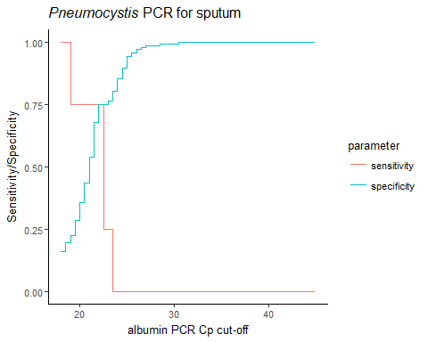 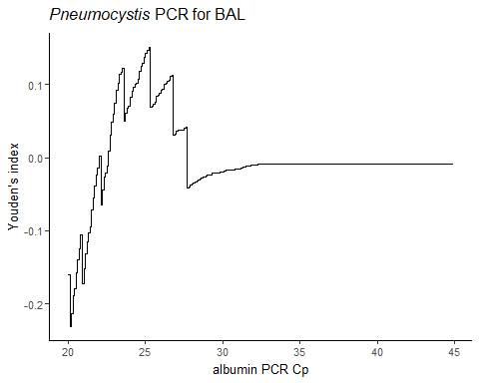 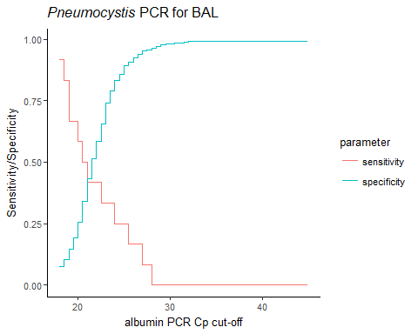

### Figure S4: Youden’s index, sensitivity and specificity of albumin PCR cut-off values for the most frequent matrixes analysed in *Pneumocystis* PCR