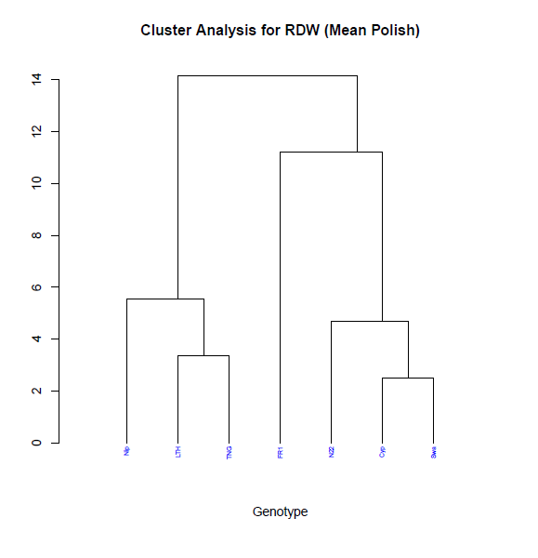cluster_RDW_nagoya_Env_July8.tiffRDW_all_MP_biplot13_july11.tiffRDW_all_MP_biplot12_july11.tiff

**S1 Fig. 1**. Analysis including the subset of 7 OryzaSNP genotypes phenotyped for RDW in the line-source system at Nagoya Univ.