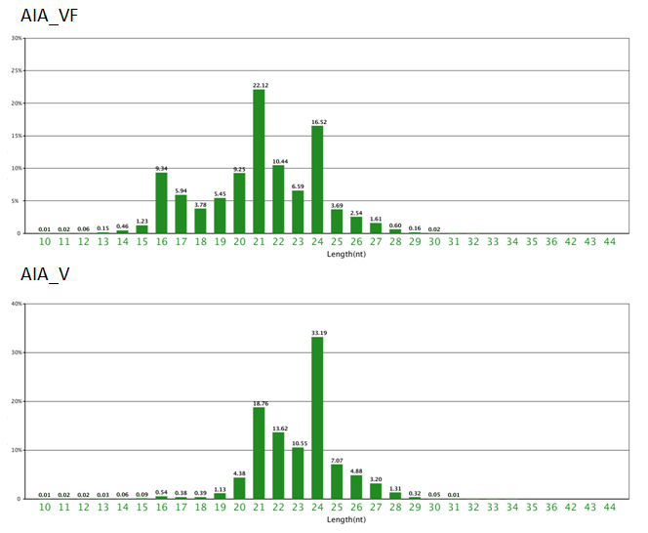

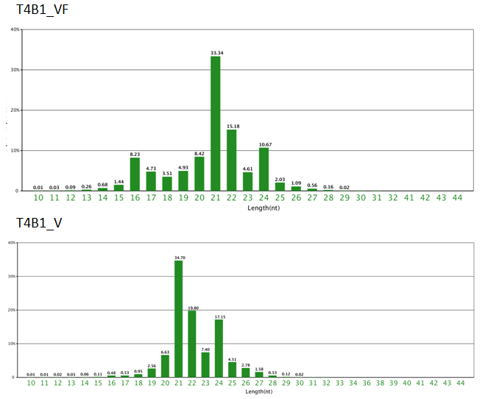

**Figure S1. The length distribution of total sRNA reads among four datasets.**