**Fig. S3A**

**H929/pLN1, DZNep 0.1 µM**

**H929/pLN1, DZNep Control**

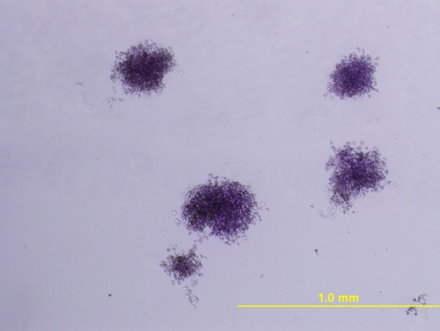 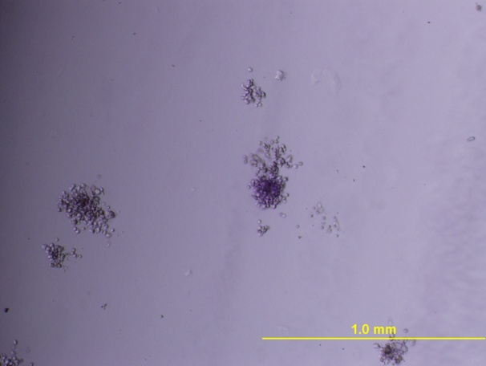

h929-pln1-dznep05-1-.tif h929-pln1-dznep05-1-.tif

**H929/pLN1, DZNep 0.5 µM**

**H929/pLN1, DZNep 1 µM**

**Fig. S3B**

**H929/ALOX5, DZNep 0.1µM**

**H929/ALOX5, Control**

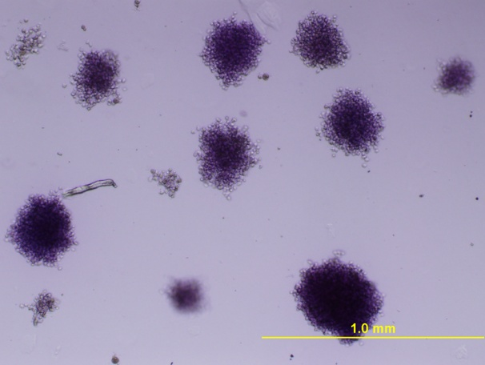 h929-alox5-dznep-01-2-.tif

h929-alox5-dznep-05-1-.tif h929-alox5-dznep-10-1-.tif

**H929/ALOX5, DZNep 0.5µM**

**H929/ALOX5, DZNep µM**

**Fig. S3C**

kms18-con-1-.tif kms18-dznep-2-.tif

**KMS18, DZNep 0.5µM +ABT-737 0.5µM**

**KMS18, ABT-737 0.5µM**

**KMS18, DZNep 0.5µM**

**KMS18, Control**

kms18-abt-737-1-.tif kms18-combination-1-.tif

**Fig. S3D**

**OPM-2, DZNep 0.5µM**

**OPM-2, Control**

opm2-con-5-.tif opm2-dznep-2-.tif

opm2-abt-1-.tif opm2-combination-1-.tif

**OPM-2, DZNep 0.5µM +ABT-737 0.5µM**

**OPM-2, ABT-737 0.5µM**