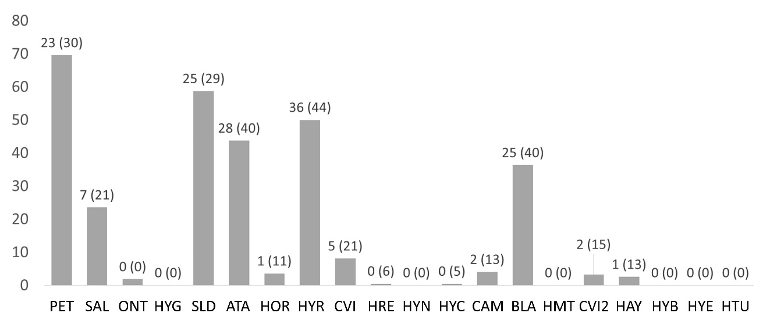
S2 Fig. Bars: percentage of satellite scenes where salt-covered pixels (TM4< 0.4) were detected after retaining potentially water covered pixels (MNDWI> 0) at each pond. The mean and standard deviation (the latter between parentheses) of the percentage of reduction are shown above

