**S9A Fig. Protein-protein docking of Survivin and Caspase-3.** Protein-protein docking of survivin (brown) and caspase-3 (yellow) was done by PatchDock Server and the result was refined by FireDock Server.



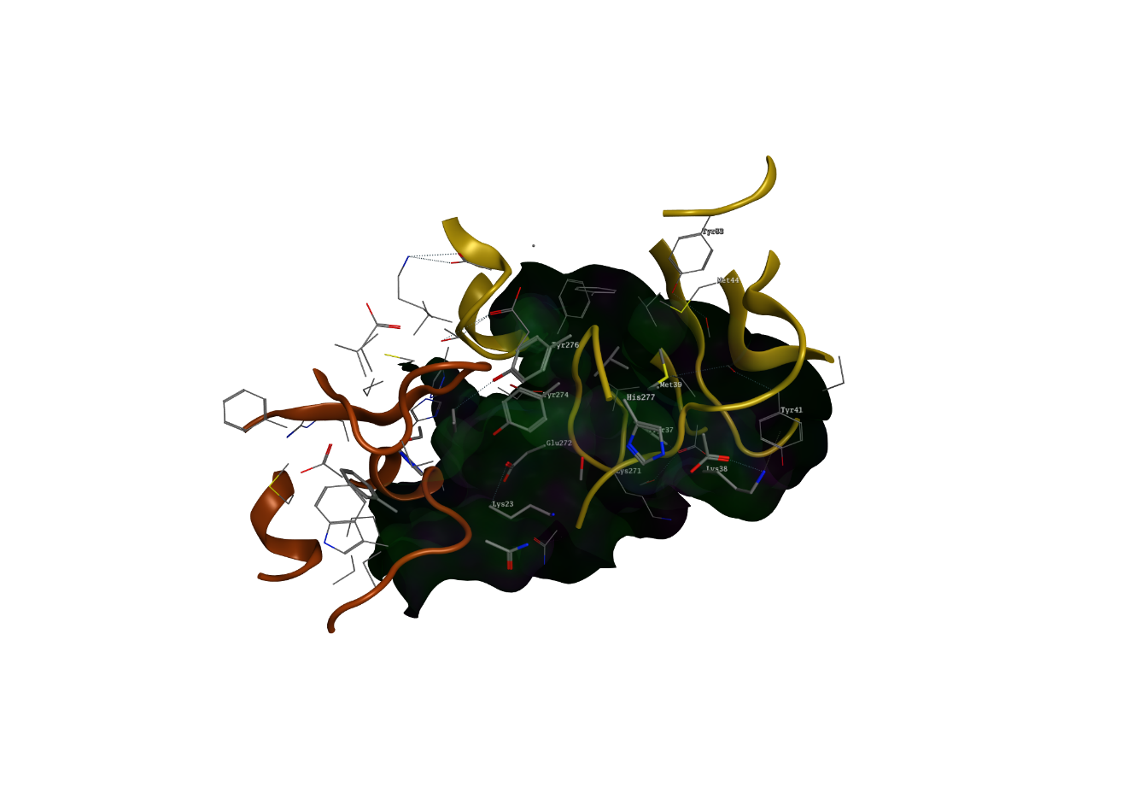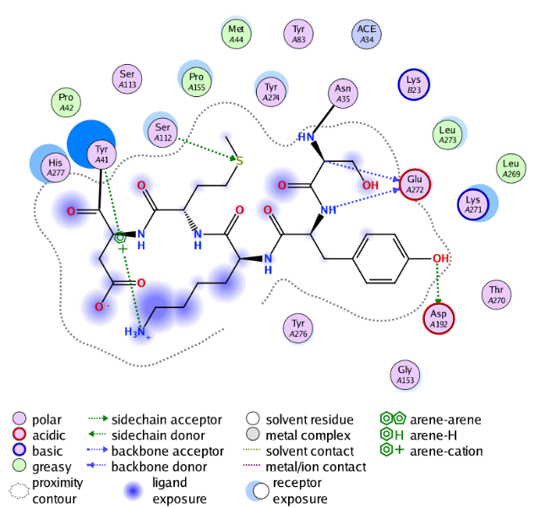

**S9B Fig. Protein-protein docking of Survivin and Caspase-9.** Protein-protein docking of survivin (brown) and caspase-9 (blue) was done by PatchDock Server and the result was refined by FireDock Server.

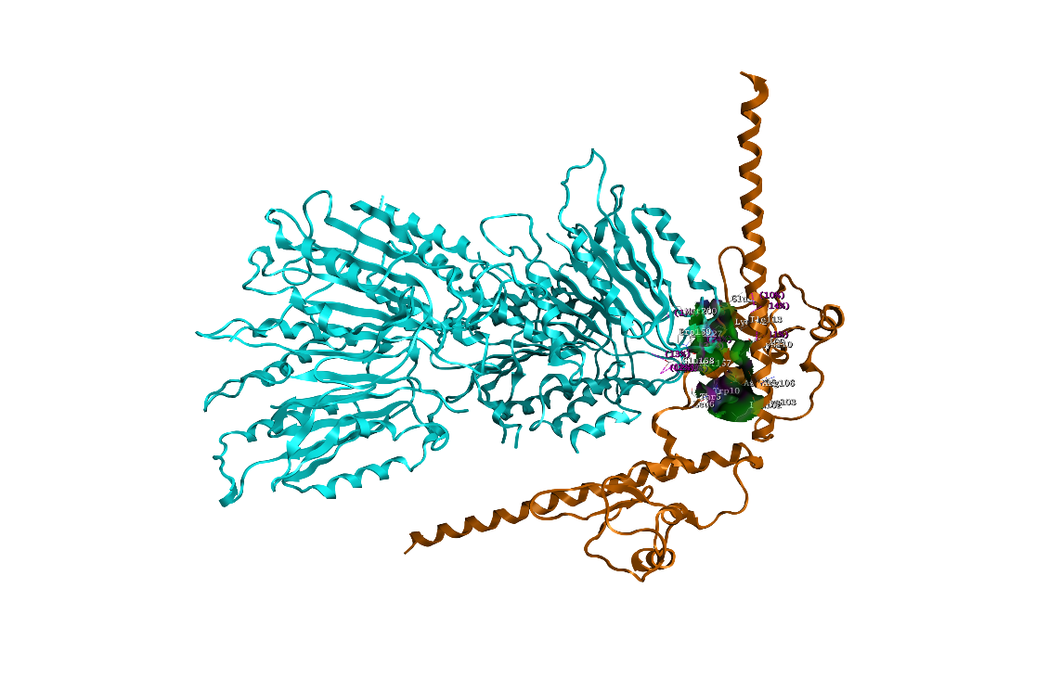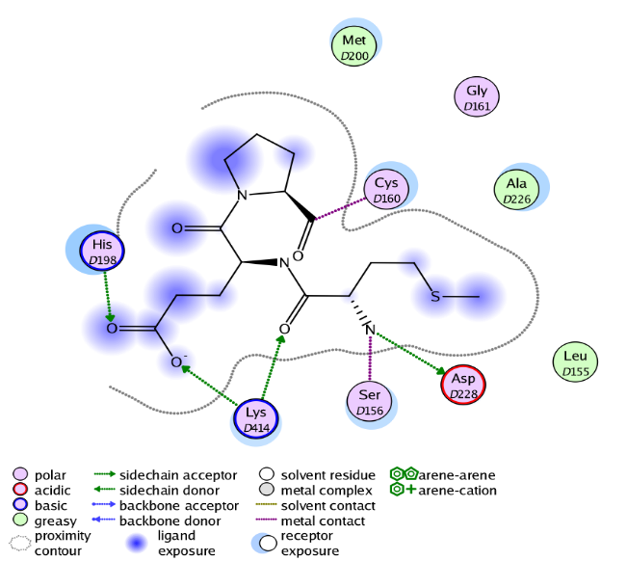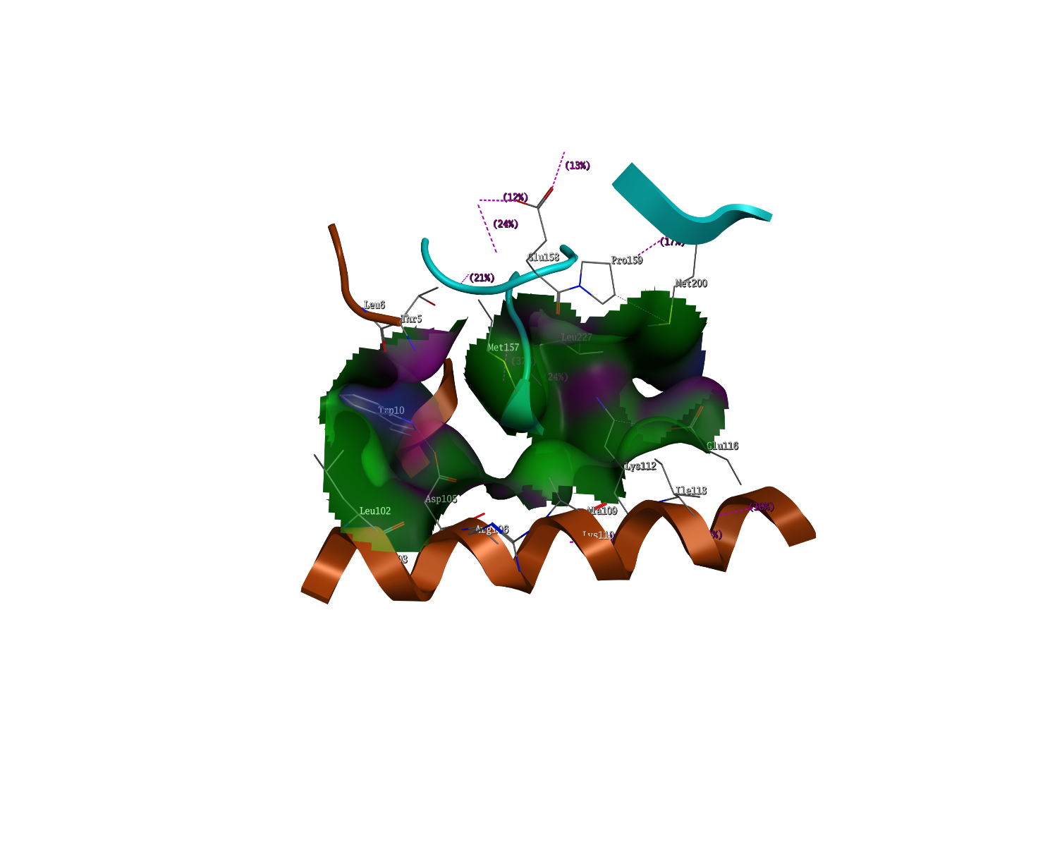

**S9C Fig. Protein – protein docking of Caspase-9 and Caspase-3.** Protein-protein docking of caspase-9 (blue) and caspase-3 (yellow) was done by PatchDock Server and the result was refined by FireDock Server.

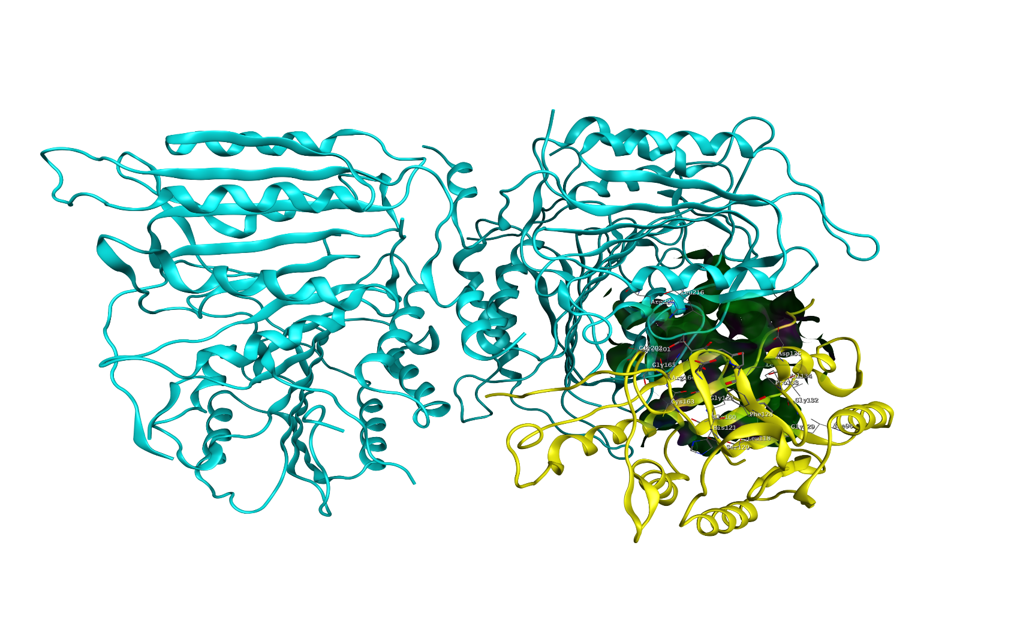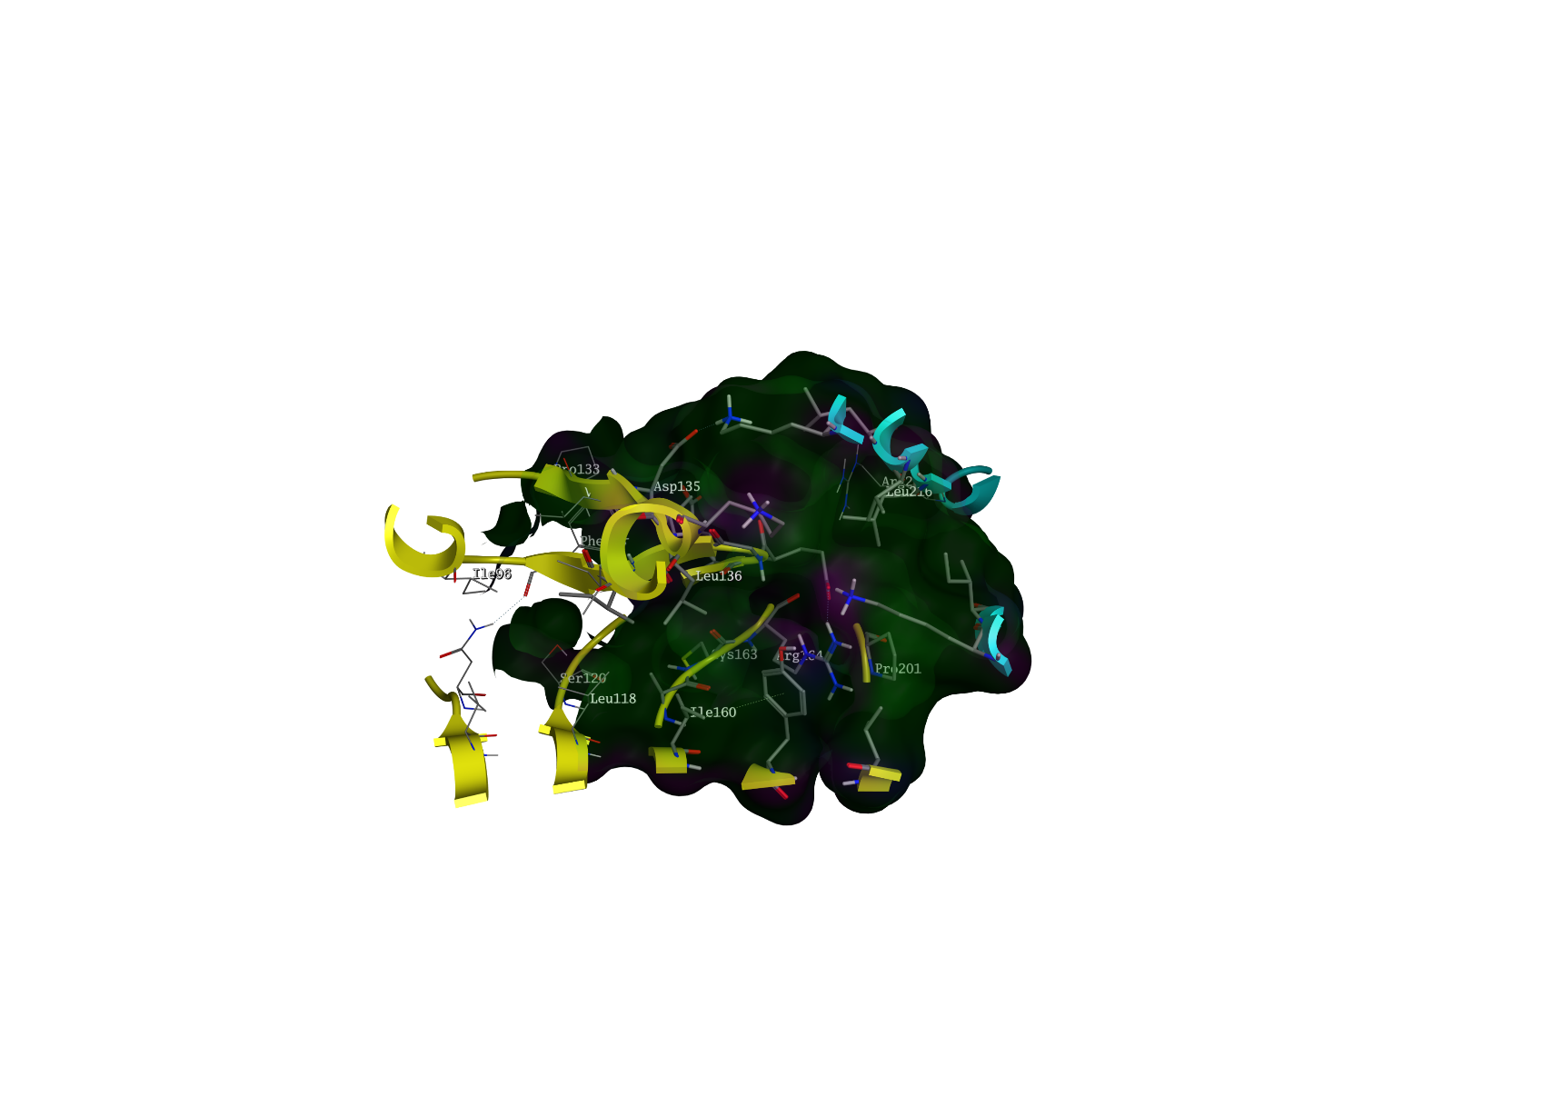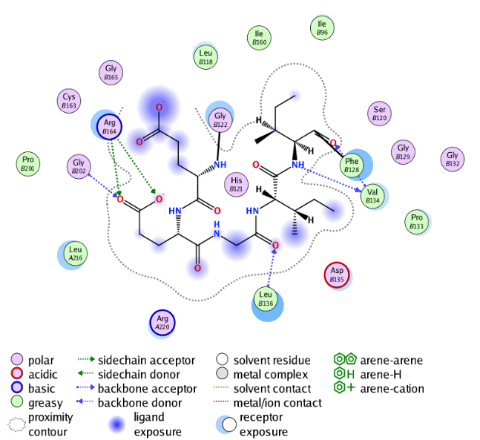

**S9D Fig. Molecular interaction of Survivin, Caspase-9 and andrographolide.** Molecular interaction of survivin (brown), caspase-9 (blue) and andrographolide (purple) was done by PatchDock Server and the result was refined by FireDock Server.

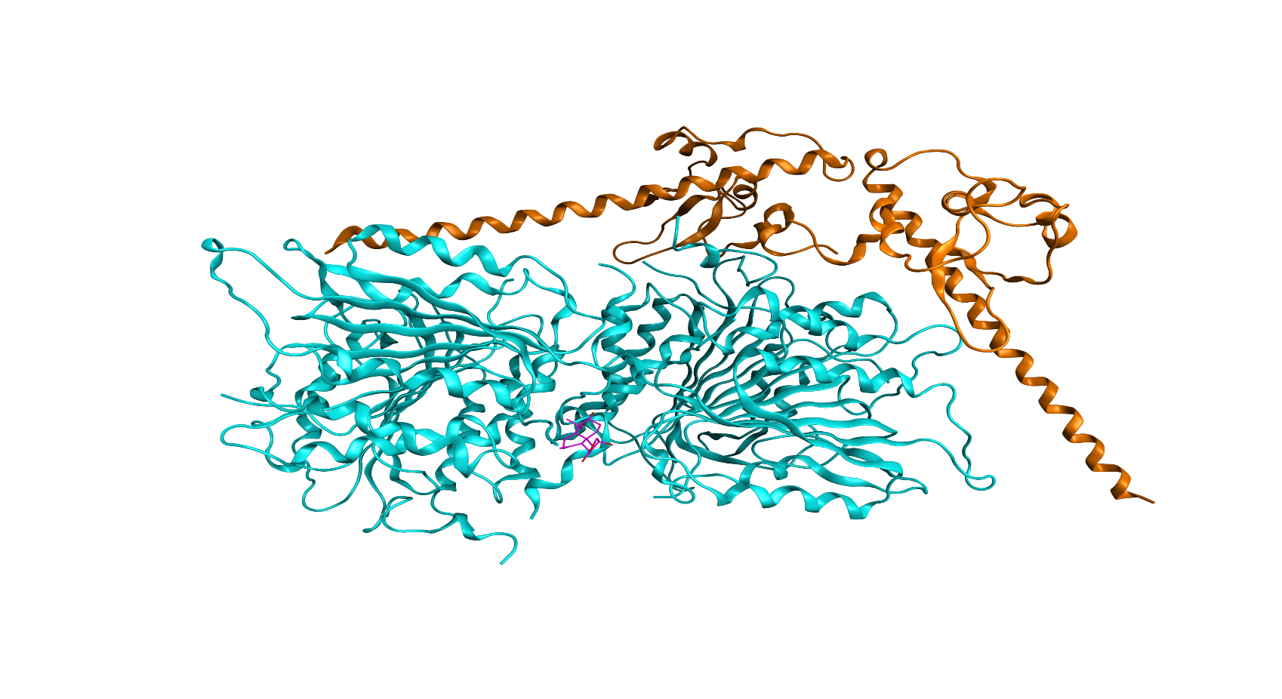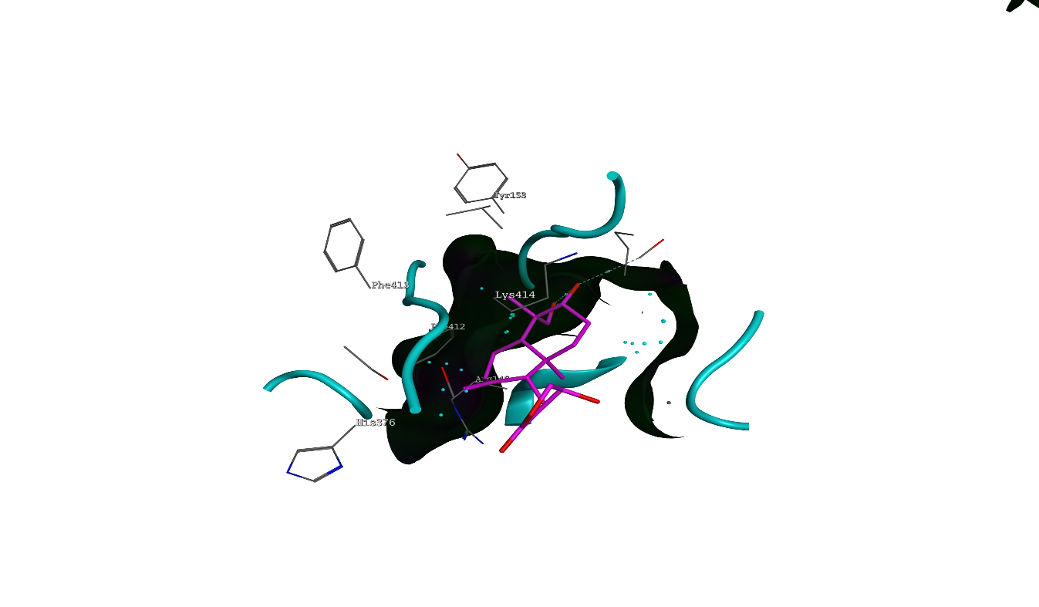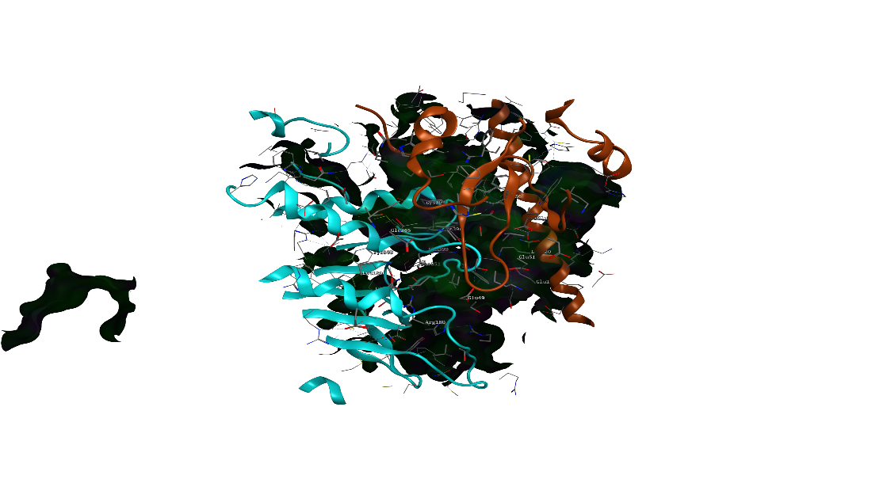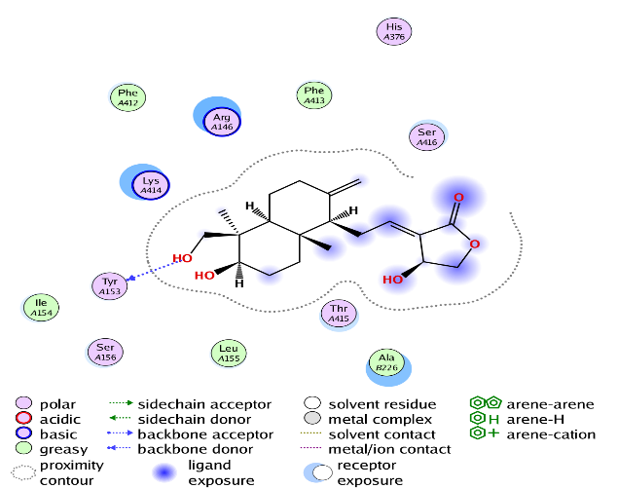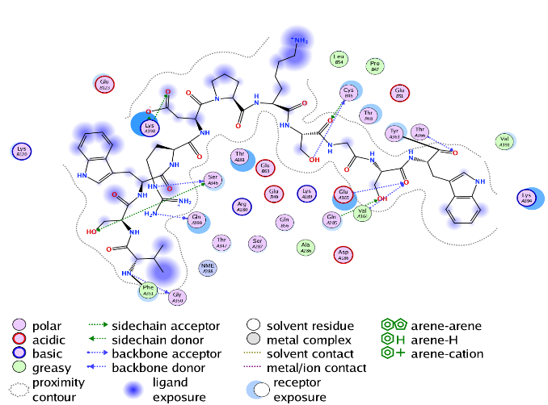

**S9E Fig. Molecular interaction of Caspase-3, Caspase-9 and andrographolide.** Molecular interaction of caspase-3 (yellow), caspase-9 (blue) and andrographolide (purple) was done by PatchDock Server and the result was refined by FireDock Server.

