**A**

**[M+H]+**

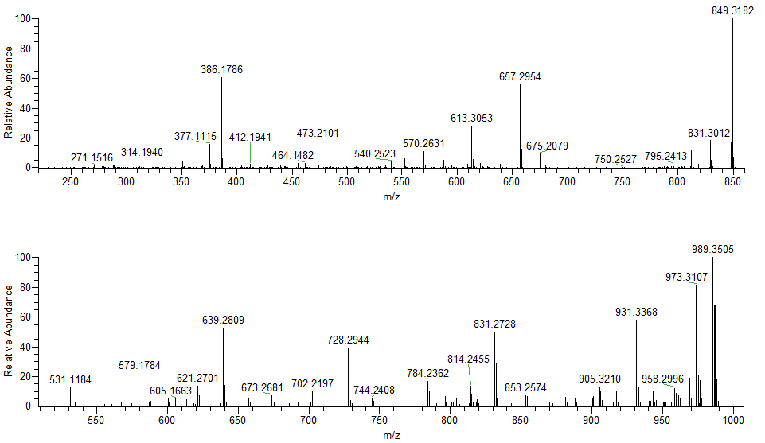

**[M+H]+ – H2O + 1,4NQ**

**[M+H]+ – H2O**

**y2**

**y3**

**b6**

G°RGDSPC°

b4

GRGDSPC°

b3

b6

b5

**B**

**[M+H]+ – H2O**