Supporting Information Contents
Figure S1. p. 2
Distribution of R₀ from sampled parameters.
Table S1. p. 3
Probability of chikungunya virus importation by location, April 2014.
Table S2. p. 5
Probability of local transmission of chikungunya virus by location in the Americas, April 2014.

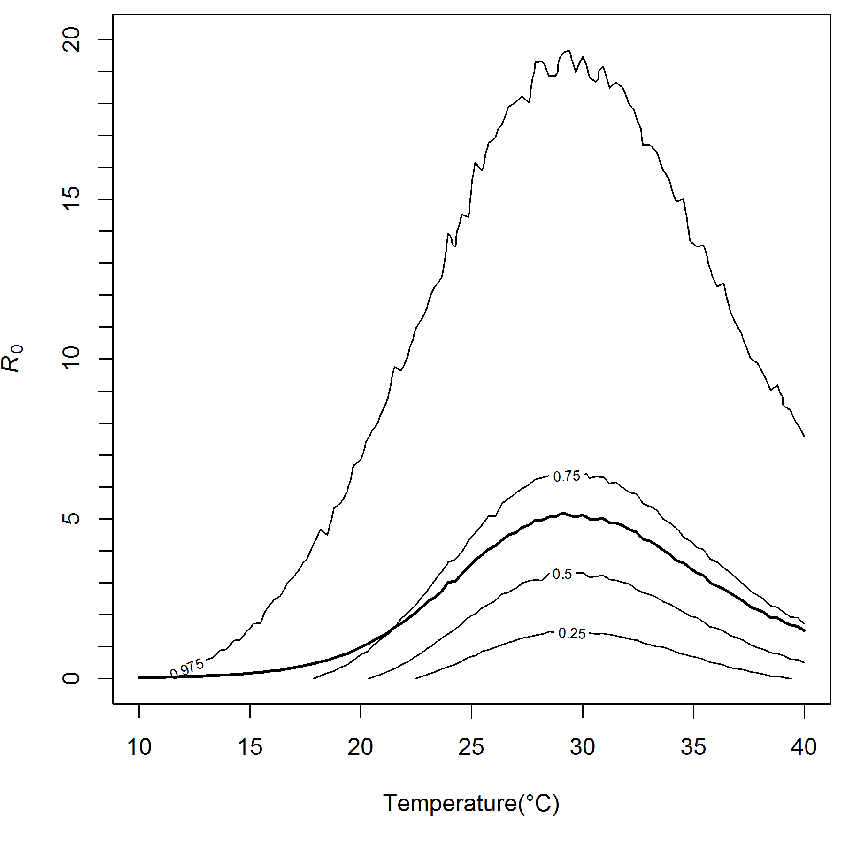

Figure S1. Distribution of R₀ from sampled parameters. For each of 10,000 sampled sets of model parameters, we calculated the R₀ value at different temperatures (). The thick line is the mean of these samples and the thin lines are the 25th, 50th, 75th, and 97.5th percentiles of that distribution.

Table S1. Probability of chikungunya virus importation by location, April 2014.*
 | mean |  | (range) |  |  | mean | (range)
Paris | 1.00 |  | (1.00-1.00) |  | Cleveland | 0.36 | (0.16-0.57)
New York | 1.00 |  | (1.00-1.00) |  | Buffalo | 0.33 | (0.15-0.54)
Miami | 1.00 |  | (0.96-1.00) |  | Berlin | 0.32 | (0.14-0.53)
Montreal | 1.00 |  | (0.94-1.00) |  | Lima | 0.32 | (0.14-0.53)
Puerto Rico | 1.00 |  | (0.93-1.00) |  | Raleigh | 0.32 | (0.14-0.52)
Barbados | 0.99 |  | (0.91-1.00) |  | San Jose, CR | 0.31 | (0.14-0.51)
Toronto | 0.98 |  | (0.83-1.00) |  | Sao Paulo | 0.30 | (0.13-0.50)
Boston | 0.97 |  | (0.80-1.00) |  | Lisbon | 0.28 | (0.12-0.48)
Marseille | 0.96 |  | (0.75-1.00) |  | St. Louis | 0.28 | (0.12-0.47)
Nice | 0.94 |  | (0.71-1.00) |  | Mauritius | 0.28 | (0.12-0.47)
Bordeaux | 0.94 |  | (0.71-1.00) |  | New Orleans | 0.27 | (0.12-0.46)
USVI | 0.94 |  | (0.70-1.00) |  | Pittsburgh | 0.27 | (0.12-0.46)
Toulouse | 0.94 |  | (0.70-1.00) |  | Stuttgart | 0.27 | (0.12-0.45)
Reunion | 0.94 |  | (0.71-1.00) |  | Seattle | 0.27 | (0.11-0.45)
Ajaccio | 0.92 |  | (0.66-1.00) |  | Bogota | 0.26 | (0.11-0.45)
Montpellier | 0.92 |  | (0.66-0.99) |  | Columbus | 0.26 | (0.11-0.44)
Toulon | 0.92 |  | (0.66-1.00) |  | Grenada | 0.25 | (0.10-0.42)
Biarritz | 0.91 |  | (0.66-0.99) |  | Edmonton | 0.24 | (0.10-0.42)
Bastia | 0.91 |  | (0.64-0.99) |  | Ottawa | 0.24 | (0.10-0.41)
Trinidad | 0.91 |  | (0.63-0.99) |  | Calgary | 0.24 | (0.10-0.41)
London | 0.90 |  | (0.61-0.99) |  | Cincinnati | 0.24 | (0.10-0.40)
Pau | 0.90 |  | (0.63-0.99) |  | Brussels | 0.23 | (0.10-0.40)
Chicago | 0.85 |  | (0.54-0.98) |  | Oslo | 0.23 | (0.10-0.40)
Barcelona | 0.85 |  | (0.54-0.98) |  | Milwaukee | 0.23 | (0.10-0.40)
Curacao | 0.83 |  | (0.54-0.98) |  | Warsaw | 0.23 | (0.10-0.40)
Brest | 0.83 |  | (0.53-0.98) |  | Valencia | 0.23 | (0.10-0.39)
Lyon | 0.83 |  | (0.52-0.97) |  | Phoenix | 0.22 | (0.09-0.37)
Philadelphia | 0.82 |  | (0.51-0.97) |  | Palma de Mallorca | 0.21 | (0.09-0.37)
Calvi | 0.80 |  | (0.49-0.97) |  | Indianapolis | 0.21 | (0.09-0.37)
Nantes | 0.80 |  | (0.48-0.96) |  | Cuba | 0.21 | (0.09-0.36)
St. Eustatius | 0.79 |  | (0.50-0.97) |  | Palermo | 0.20 | (0.09-0.36)
Washington DC | 0.79 |  | (0.48-0.96) |  | Rochester | 0.20 | (0.08-0.35)
Basel | 0.77 |  | (0.46-0.95) |  | Mexico City | 0.20 | (0.08-0.35)
Saba | 0.77 |  | (0.48-0.96) |  | Portland | 0.20 | (0.08-0.35)
Istanbul | 0.76 |  | (0.45-0.95) |  | Syracuse | 0.20 | (0.08-0.35)
Fort Lauderdale | 0.75 |  | (0.43-0.94) |  | Perpignan | 0.20 | (0.08-0.35)
Los Angeles | 0.74 |  | (0.43-0.94) |  | Richmond | 0.20 | (0.08-0.34)
Amsterdam | 0.73 |  | (0.42-0.93) |  | Rio De Janeiro | 0.20 | (0.08-0.34)
Atlanta | 0.72 |  | (0.41-0.92) |  | Manchester | 0.20 | (0.08-0.34)
Stockholm | 0.71 |  | (0.41-0.93) |  | Las Vegas | 0.19 | (0.08-0.33)
Orlando | 0.70 |  | (0.39-0.91) |  | Oran | 0.19 | (0.08-0.33)
Charlotte | 0.69 |  | (0.38-0.90) |  | Georgetown, GY | 0.18 | (0.08-0.32)
Clermont-Ferrand | 0.66 |  | (0.36-0.89) |  | Vancouver | 0.18 | (0.07-0.31)
Strasbourg | 0.66 |  | (0.36-0.89) |  | Quito | 0.17 | (0.07-0.30)
Frankfurt | 0.63 |  | (0.33-0.86) |  | Providence | 0.17 | (0.07-0.30)
Detroit | 0.62 |  | (0.32-0.85) |  | Quimper | 0.17 | (0.07-0.29)
Baltimore | 0.60 |  | (0.31-0.84) |  | Prague | 0.16 | (0.06-0.28)
Madrid | 0.58 |  | (0.30-0.83) |  | Cordoba | 0.16 | (0.06-0.28)
Quebec City |  | 0.57 | (0.29-0.81) |  | Lourdes | 0.15 | (0.06-0.27)
Caracas |  | 0.53 | (0.26-0.78) |  | Rennes | 0.15 | (0.06-0.26)
Geneva |  | 0.53 | (0.25-0.76) |  | Paramaribo | 0.15 | (0.06-0.26)
Moscow |  | 0.50 | (0.25-0.75) |  | St. Petersburg | 0.15 | (0.06-0.26)
Milan |  | 0.50 | (0.24-0.74) |  | Luxembourg | 0.14 | (0.06-0.25)
Buenos Aires |  | 0.49 | (0.24-0.74) |  | Norfolk | 0.14 | (0.06-0.25)
Duesseldorf |  | 0.49 | (0.23-0.73) |  | Bilbao | 0.14 | (0.06-0.24)
Hartford |  | 0.49 | (0.24-0.74) |  | Lorient | 0.13 | (0.05-0.24)
Munich |  | 0.49 | (0.23-0.73) |  | Bejaia | 0.13 | (0.05-0.24)
Rome |  | 0.48 | (0.23-0.72) |  | Ibiza | 0.13 | (0.05-0.24)
Minneapolis |  | 0.48 | (0.23-0.72) |  | Salt Lake City | 0.13 | (0.05-0.24)
Algiers |  | 0.47 | (0.22-0.71) |  | Setif | 0.13 | (0.05-0.23)
Copenhagen |  | 0.46 | (0.21-0.69) |  | Kansas City | 0.12 | (0.05-0.22)
Halifax |  | 0.45 | (0.22-0.70) |  | Belo Horizonte | 0.12 | (0.05-0.22)
Zurich |  | 0.45 | (0.21-0.69) |  | Jacksonville | 0.12 | (0.05-0.21)
San Francisco |  | 0.45 | (0.21-0.68) |  | Nashville | 0.12 | (0.05-0.21)
Panama City |  | 0.44 | (0.21-0.68) |  | Louisville | 0.12 | (0.05-0.21)
Denver |  | 0.43 | (0.20-0.67) |  | San Diego | 0.11 | (0.05-0.21)
Tampa |  | 0.43 | (0.20-0.66) |  | Alicante | 0.11 | (0.05-0.21)
Bonaire |  | 0.43 | (0.20-0.67) |  | Bologna | 0.11 | (0.04-0.20)
Santiago |  | 0.42 | (0.19-0.66) |  | Hong Kong | 0.11 | (0.04-0.20)
Dallas |  | 0.41 | (0.19-0.64) |  | Lille | 0.11 | (0.04-0.20)
Vienna |  | 0.41 | (0.19-0.64) |  | Dublin | 0.11 | (0.04-0.20)
Hamburg |  | 0.40 | (0.18-0.63) |  | Albany | 0.11 | (0.04-0.19)
Houston |  | 0.38 | (0.17-0.60) |  | Beijing | 0.10 | (0.04-0.19)
Jamaica |  | 0.38 | (0.17-0.60) |  | Porto Alegre | 0.10 | (0.04-0.19)
Budapest |  | 0.37 | (0.17-0.60) |  | Burlington | 0.10 | (0.04-0.19)
Tunis |  | 0.37 | (0.17-0.59) |  | Lalle | 0.10 | (0.04-0.19)
*For all locations with mean p > 0.10.
Table S2. Probability of local transmission of chikungunya virus by location in the Americas, April 2014.*

 | mean | (range)
Puerto Rico | 0.96 | (0.24-1.00)
Miami | 0.93 | (0.05-1.00)
Barbados | 0.92 | (0.26-1.00)
USVI | 0.77 | (0.12-0.99)
Trinidad | 0.75 | (0.14-0.98)
Curacao | 0.62 | (0.10-0.95)
St. Eustatius | 0.55 | (0.06-0.93)
Saba | 0.53 | (0.05-0.91)
Fort Lauderdale | 0.43 | (0.01-0.86)
Caracas | 0.37 | (0.05-0.69)
Orlando | 0.32 | (0.00-0.79)
Panama City | 0.28 | (0.03-0.59)
Bonaire | 0.27 | (0.03-0.58)
Aruba | 0.27 | (0.03-0.57)
Jamaica | 0.24 | (0.02-0.51)
San Jose, CR | 0.19 | (0.02-0.43)
Tampa | 0.17 | (0.00-0.50)
Grenada | 0.15 | (0.01-0.34)
Georgetown, GY | 0.11 | (0.01-0.26)
Cuba | 0.10 | (0.00-0.28)
*For all locations with mean p > 0.10.

