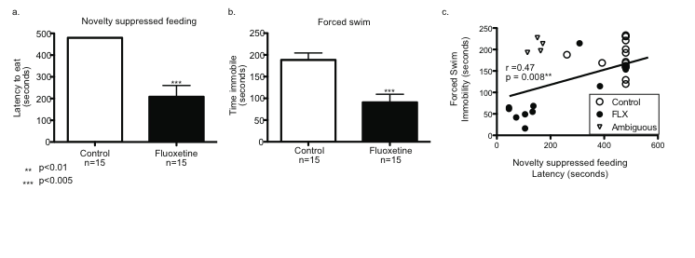

**Figure S1: Variability present in behavioral response to fluoxetine.** All mice (n = 30) were chronically (21 days) treated with corticosterone (CORT) (35 ug/ml) in the drinking water. Fifteen mice were also co-administered fluoxetine (FLX) (160ug/ml). Following chronic treatment mice were tested in the Forced Swim Test (FST) and Novelty Suppressed Feeding paradigm (NSF). At the group level FLX-treated mice demonstrated significantly decreased latency to eat in the NSF (panel a: P < 0.005) and decreased immobility in the NSF (panel b: P < 0.005). At the individual level there was a significantly correlation between latency to eat (x-axis) and immobility (y-axis) (Spearman r = 0.47, p = 0.008). Four mice (Ambiguous – open triangles) appeared to respond in the NSF but not in the FST. These mice were not used for microarray experiments.