**Figure A: Analytical Gel Filtration Results. *Anthony A. Emanuele and George A. Garcia***

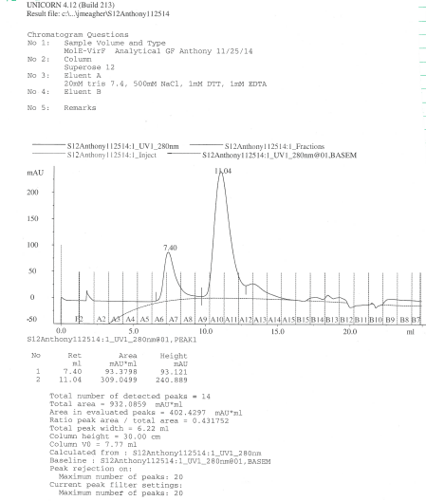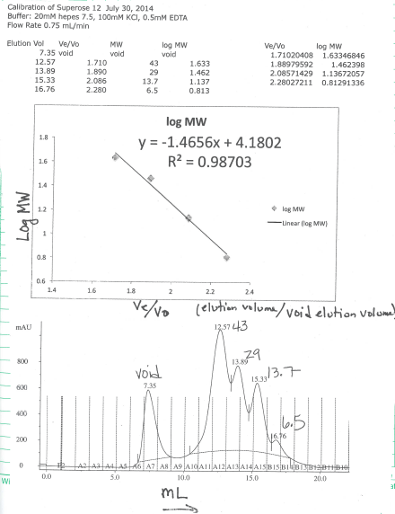**I II**

I) Chromatogram depicting elution of MalE-VirF (11.04 mL) from Superose 12 column. II) Chromatogram and four-point calibration curve for Superose 12 column used to determine molecular weight of MalE-VirF in I.

**Figure B: Negative Controls for EMSA and FP assay.**

**I**

**II**

I) EMSA image shows the retardation of the 5’Cy5-*pvirB* DNA probe (0.25 μM) when incubated in the presence of MalE-VirF (1 μM) and shows no retardation of the 5’Cy5-*pScram* DNA probe (0.25 μM) when incubated in the presence of MalE-VirF (1 μM). II) Graph depicting the anisotropy values generated in the FP assay for the 5’Fluorescein *pScram* probe alone (r = 39) and in the presence of MalE-VirF (r = 36). Experiments were conducted in duplicate with 50 nM *pScram* and 20 μM MalE-VirF.

**Table A: Fluorescence Intercalator Displacement Assay with 10 bp *pvirB* Probes.**

|  |  |  |
| --- | --- | --- |
| **10 bp *pvirB* Fragment** | **19615 (2 μM) %fluorescence** | **Berenil (2 μM) %fluorescence** |
| *pvirB* 1-10 (5’-AGAATATTAT-3’) | 93% ± 6% | 45% ± 2% |
| *pvirB* 11-20 (5’-TCTTTTATCC -3’) | 95% ± 3% | 66% ± 0% |
| *pvirB 2*1-30 (5’-AATAAAGATA -3’) | 92% ± 1% | 81% ± 4% |
| *pvirB 3*1-40 (5’-AATTGCATCA -3’) | 94% ± 2% | 89% ± 5% |
| *pvirB 4*1-50 (5’-ATCCAGCTAT -3’) | 94% ± 1% | 96% ± 2% |
| *pvirB 5*1-60 (5’-TAAAATAGTA -3’)* | 92% ± 0% | 67% ± 0% |

\**pvirB* 51-60 was selected for use in the dose-response FID assay since it was sensitive to Berenil (67%) and was the most sensitive to 19615 (92%) in this study. The differential affinity of Berenil for the various 10 BP fragments reflects its preference for specific AT-rich sequences.

**Figure C: EMSA depicting *E. coli* RNA Polymerase (RNAP) Binding to the *lac* Promoter (*plac*) in the Presence of 19615.** EMSA image shows the retardation of a 5’Cy5-*plac* DNA probe (0.25 μM) when incubated in the presence of *E. coli* RNAP (core and holoenzyme with sigma70 at 2.7 μM) and also shows that compound 19615 has no effect on RNAP binding when tested at 100 μM. For the EMSA a hybrid 2% acrylamide, 1% agarose gel was used which was made with and ran in a 1X TGE buffer (25 mM Tris base, 190 mM glycine, 1 mM EDTA, pH 8.3). The sequence of the 5’Cy5-*plac* DNA probe is as follows: 5’-gtgccctggtctggTTAGGCACCCCAGGCTTTACACTTTATGCTTCCGGCTCGTATAATGTGTGGAATTGTGAG-3’ (lowercase text represents LUEGO sequence, uppercase text represents *lac* promoter sequence).