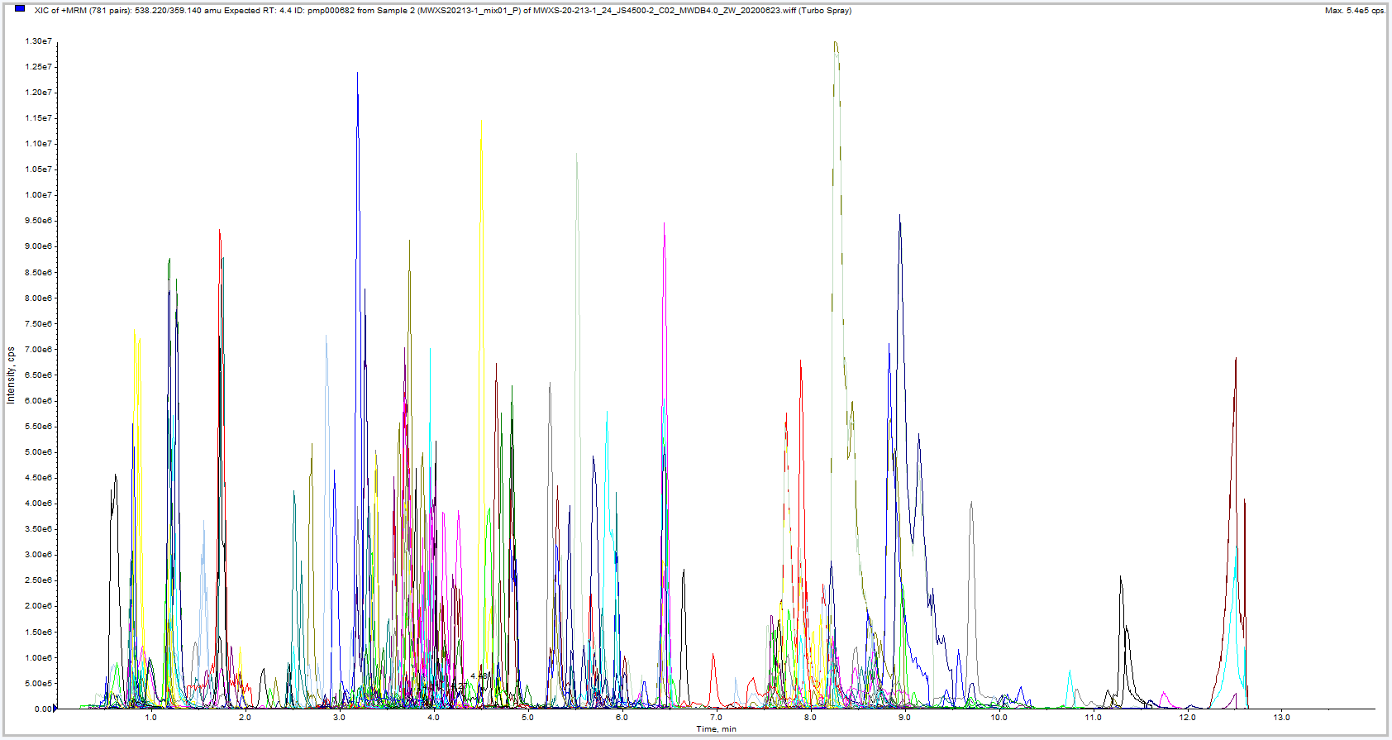
S3 Fig. Multi-peak detection plot of metabolites acquired in positive ion multiple reaction monitoring mode

