**Figure S3.** Regional Association Plot from Population-based Colorectal Cancer Case Control Analysis in 4q21.1

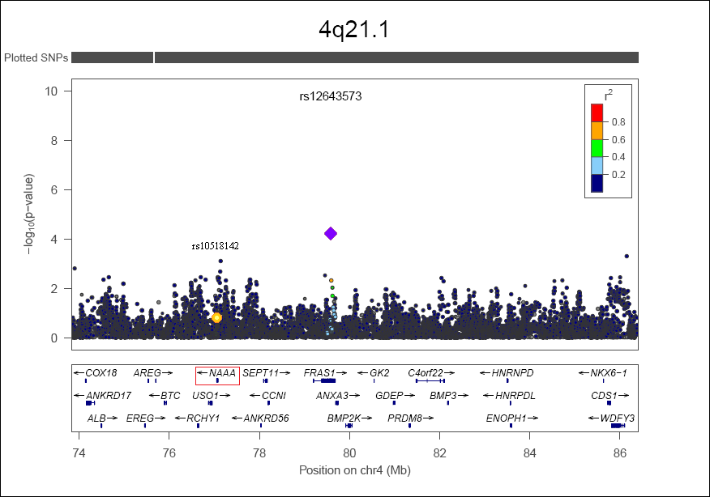



rs10518142

rs12643573

