**SUPPLEMENTARY MATERIAL**

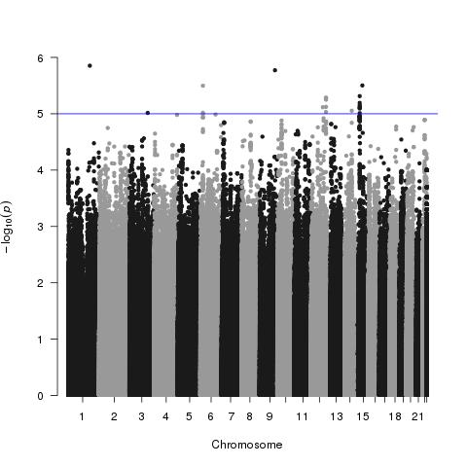

Figure S1. Genome-wide Manhattan plot for hippocampal volume using the Sydney Memory and Ageing Study Cohort. *P*-values for each individual SNP are plotted against chromosome position from the results of the association analysis with bilateral hippocampal volume. The analysis was adjusted for age, sex, scanner and ICV.