**S1 Fig. Estimation of total large-herbivore carrying capacity (*Ktot*).** Data are from Tinley [1]. Blue lines show 90th and 10th quantile regression lines, used as estimates of upper and lower plausible estimates of *Ktot*, respectively; red line shows ordinary least squares regression. Thin gray lines show estimates of mean annual precipitation (vertical) and biomass density (horizontal) in Gorongosa for the nine large herbivore species surveyed from 1969–1972 [2].

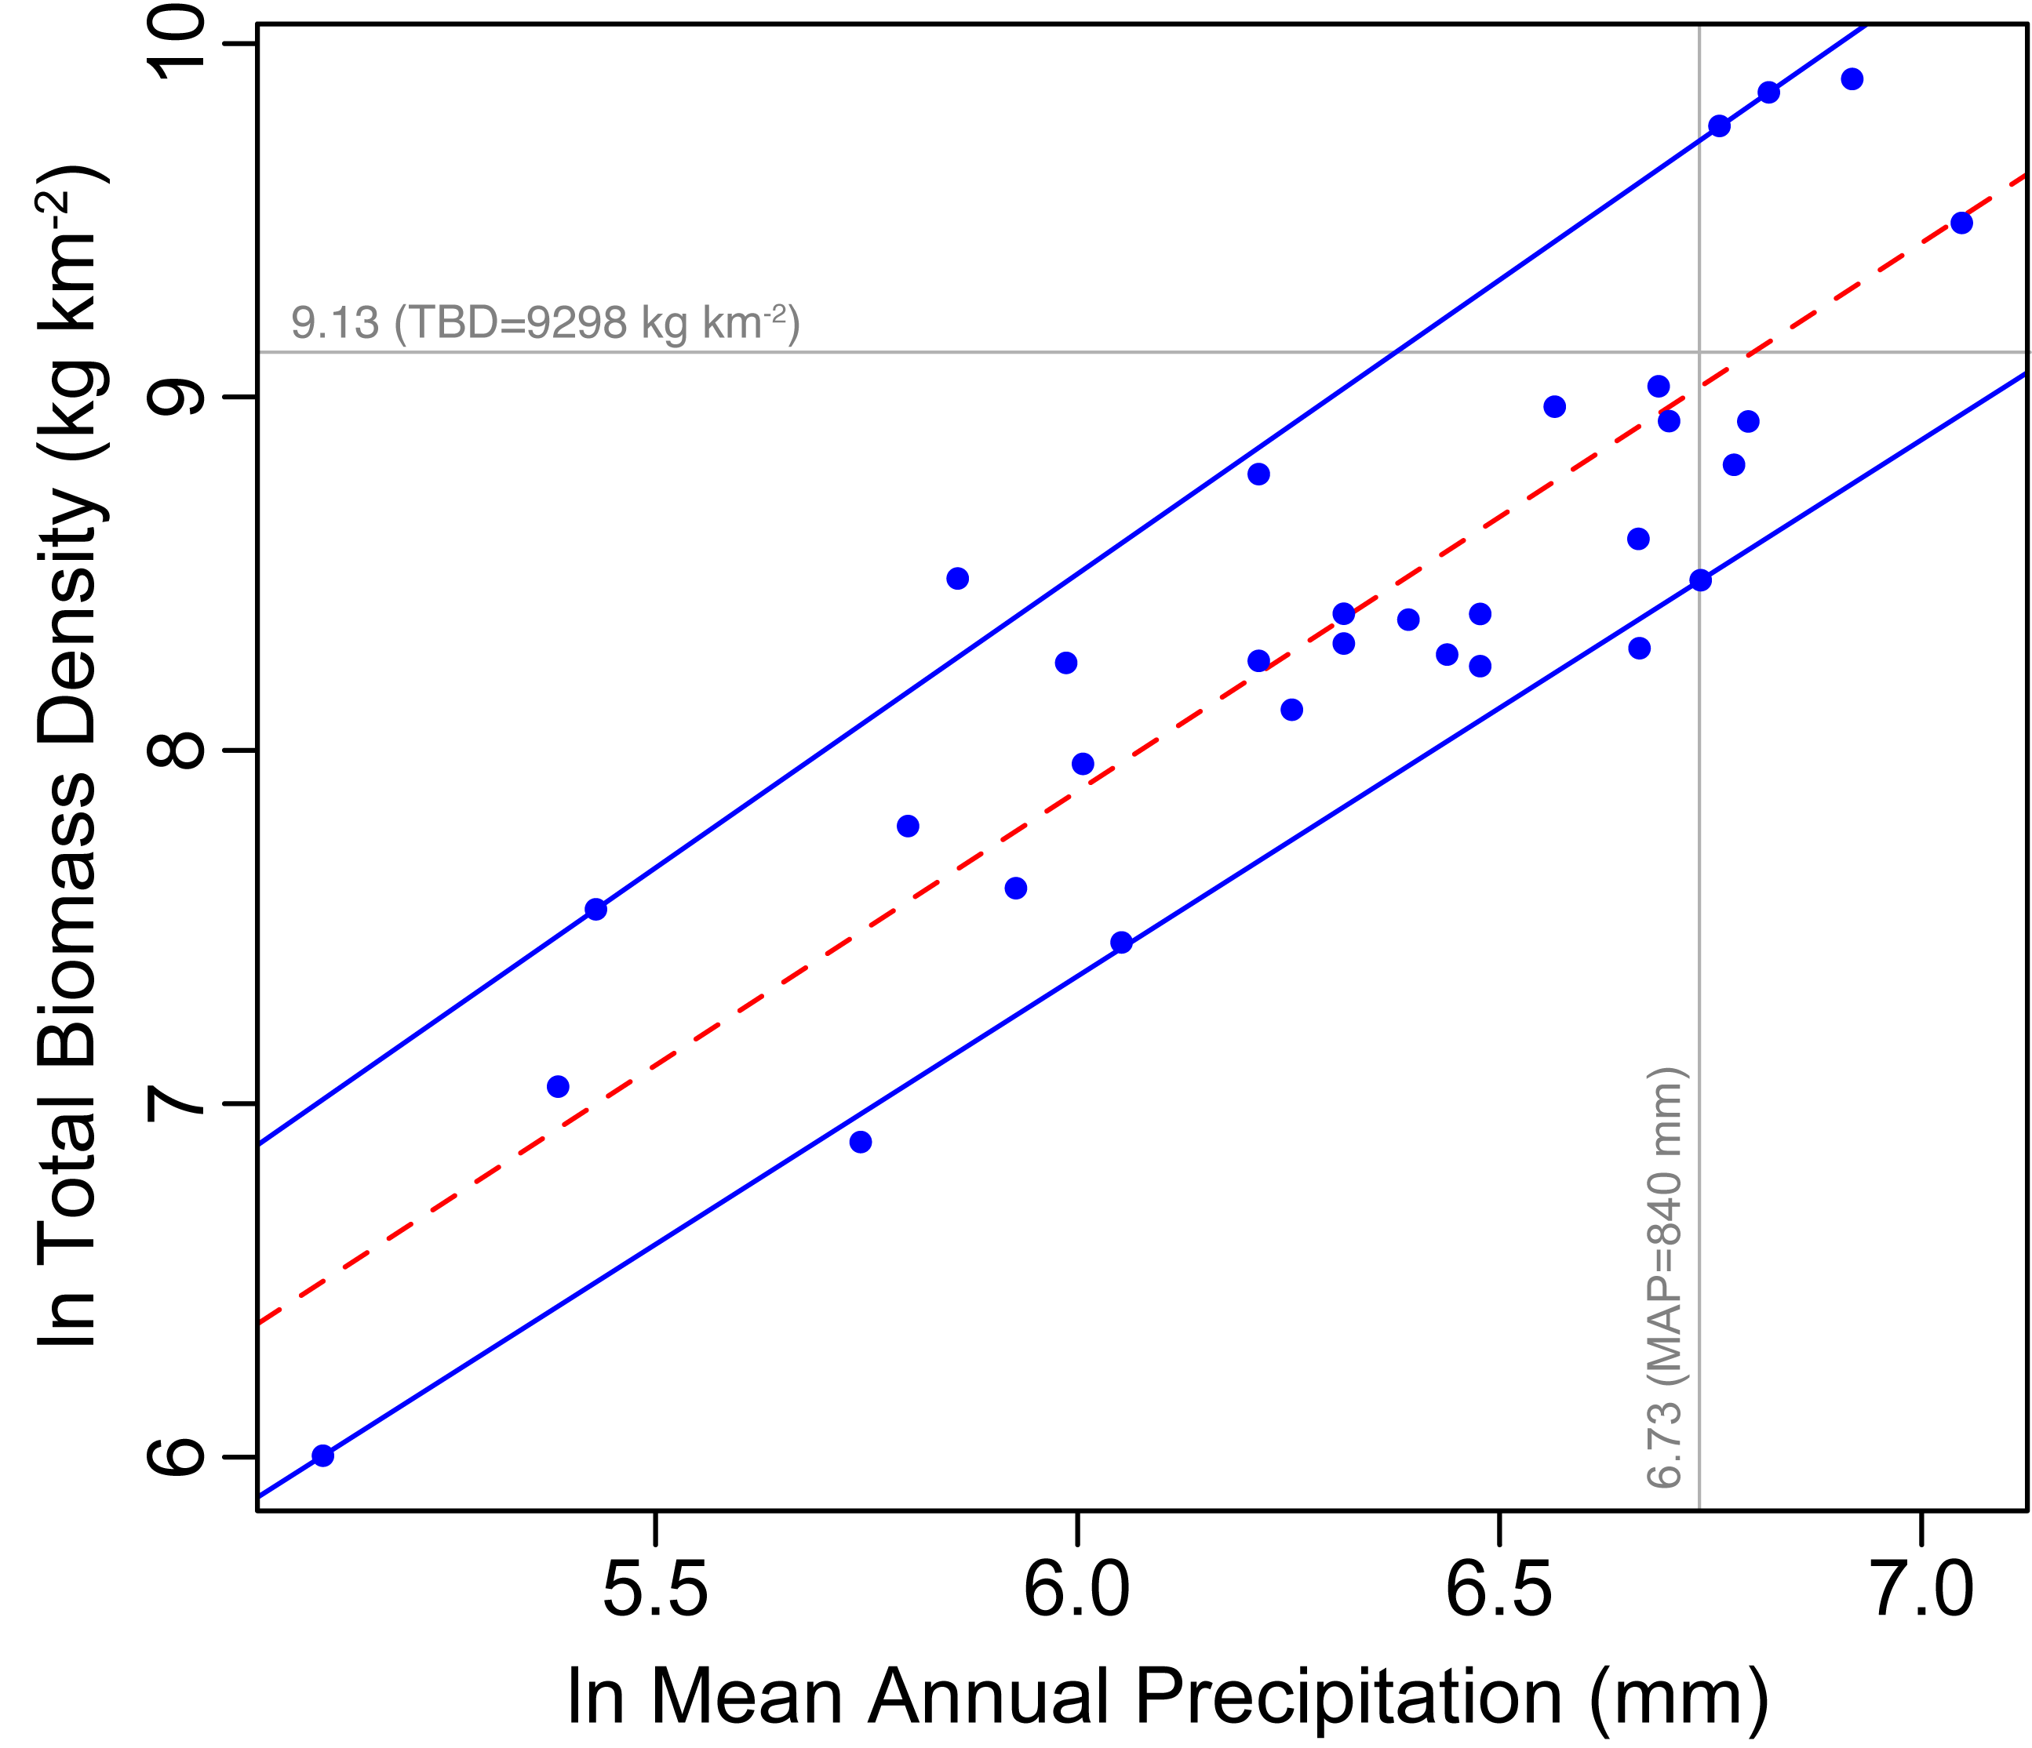

**References**

1. MJ, Cumming DH & Phillipson J (1976). Biomass and production of large African herbivores in relation to rainfall and primary production. *Oecologia* 22:341-354.
2. Tinley KL (1977) Framework of the Gorongosa Ecosystem. Ph.D. thesis. University of Pretoria, South Africa.