Supplemental Information:
S3 File: Pedigrees
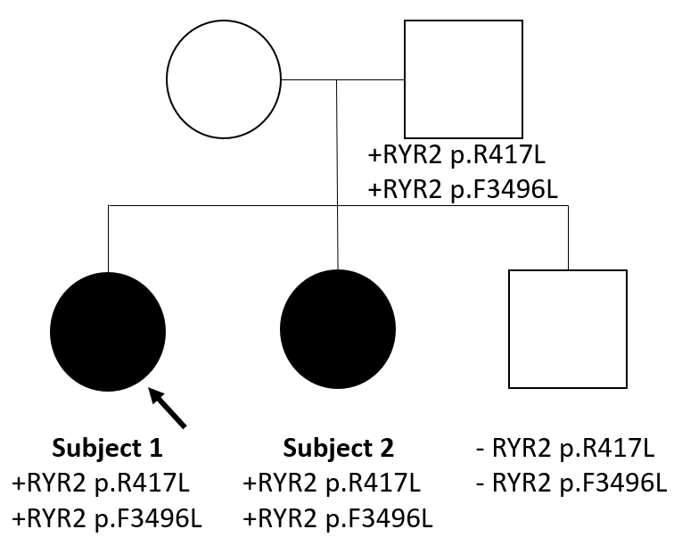

Pedigree 1: Family of Subjects 1 and 2
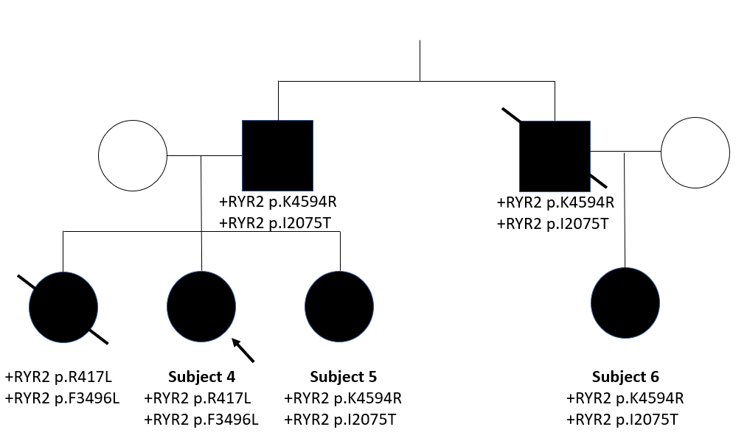

Pedigree 2: Family of Subjects 4, 5 & 6
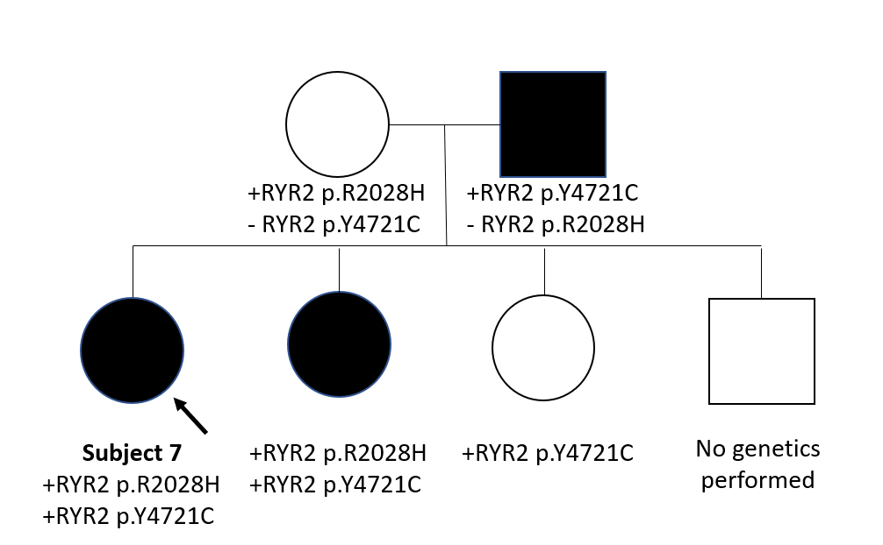

Pedigree 3: Family of Subject 7
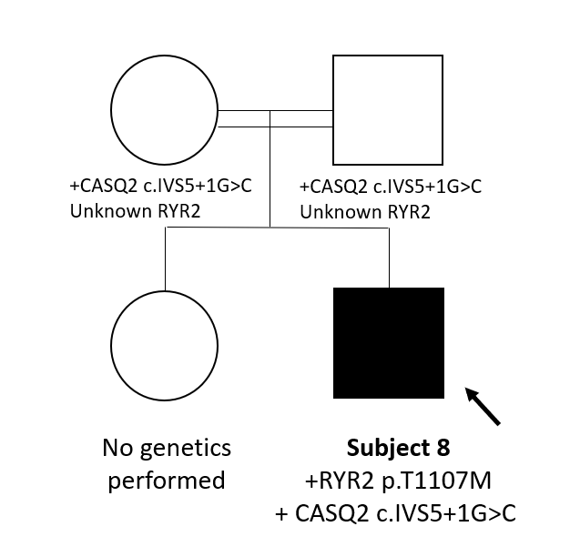

Pedigree 4: Family of Subject 8 (note parents are 1st degree cousins)

